## **What you'll learn**

* The four most common Grant Types from OAuth.
* Create and manage applications in Okta.
* Securing an existing API using Anypoint Platform.
* Create a Mule App in Anypoint Studio to retrieve tokens implementing the four Grant Types flows.
* Test the application and interact with the API using an access token.

## **What you'll need**

* Anypoint Platform account
* Anypoint Studio (last version available)
* Okta Developer account
* Postman (or another API Testing app)

**Note**: If you aren't using Postman, you probably won't have the same functionality as the explanation requires. So, for a better experience, download it!

In this Codelab we are going to learn the four most common grant types from OAuth and how to implement each flow using Anypoint Studio and the OAuth connector. These grant types are:

* Client Credentials
* Authorization Code
* Resource Owner Password
* Implicit

The important thing to remember is that both **client credentials** and **resource owner password** flows are *non-interactive*. Meaning that the final user (a.k.a. *resource owner*) doesn't have to interact once the token request is sent. These Grant Types are mainly used for service-to-service integrations where there is no human intervention.

On the other hand, **authorization code** and **implicit** flows are *interactive*. At some point, the resource owner will be asked to login to Okta and identify who they are. These Grant Types are used on interactive applications, like web or mobile, to get a token securing the resource owner credentials (they never go though the Client App).

## 

## 

## **Differences Between OAuth2 Grant Type Flow Diagrams**

In principle, the Get Access Token flow has 5 steps (as shown in the diagram below):

1. Pre-register Client (App) with OAuth Server to get Client ID/Client Secret
2. OAuth Server authenticates users presenting a login page. Sometimes it also receives the App's Client ID.
3. OAuth Server solicits user permission (consent) to allow the App to perform something on her behalf
4. OAuth Server sends secret Code (a.k.a. Authorization Code) to App
5. App acquires Key/Access Token from OAuth Server by presenting secret Code and Client Secret 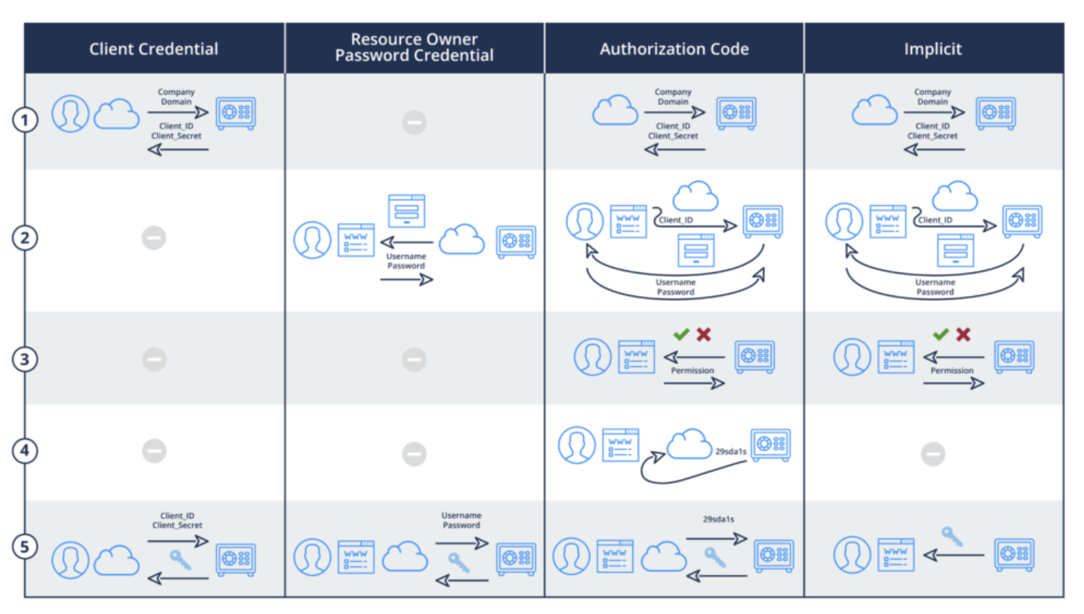

If you want to learn more about these diagrams and Grant Types in OAuth visit this link:

<https://blog.oauth.io/introduction-oauth2-flow-diagrams/>

However, later on, we will have a deeper look and see how each grant type works in detail.

In this Step, we are going to create two Apps in Okta (a Web and a Native app) to later interact with them from a Mule App we are going to create. The type of the app will enable specific Grant Types that make sense for each scenario.

We will configure each app with their callbacks, Grant Types allowed, scopes, etc.

**1.** First of all, you will need to create an Okta developer account. Later on, we will create and manage applications from Okta.

Get the trial account here:

[Okta Developer Account](https://developer.okta.com/signup/)

**2.** Create a Web App in Okta. We will name it **oauth-grant-types**. 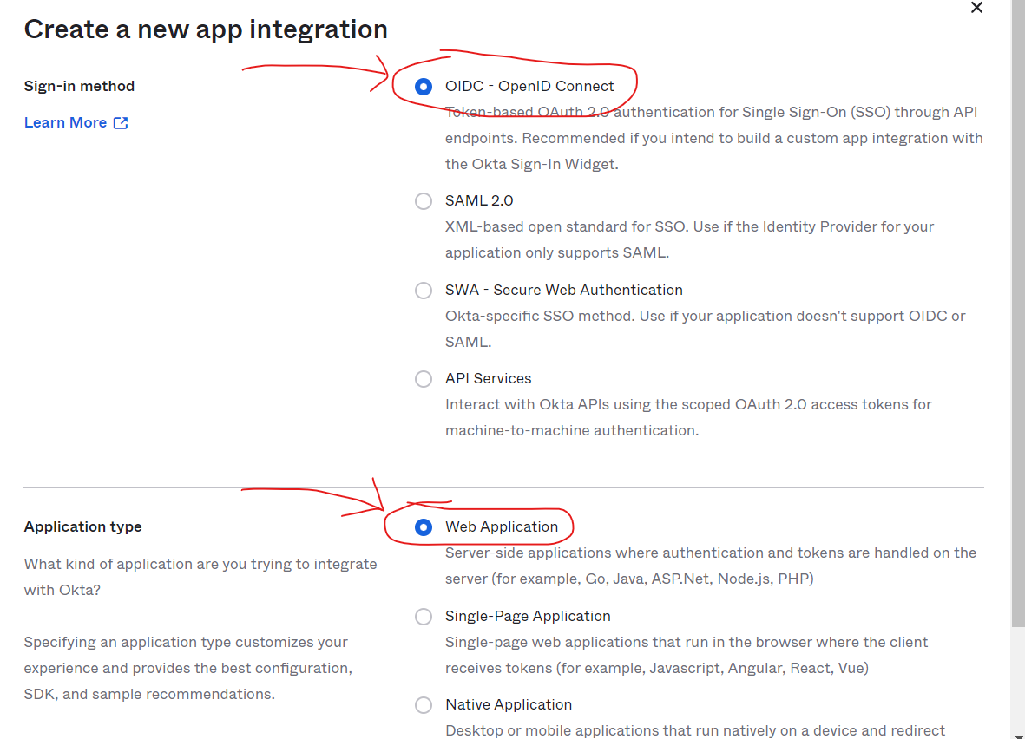

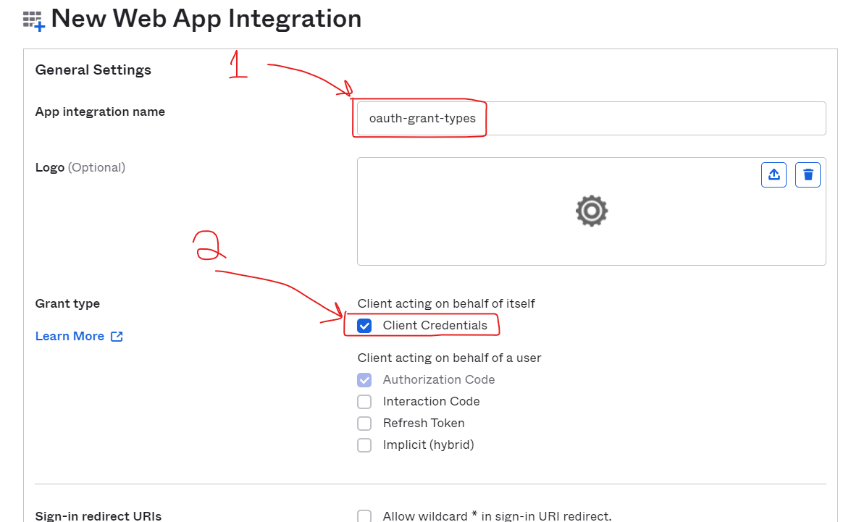

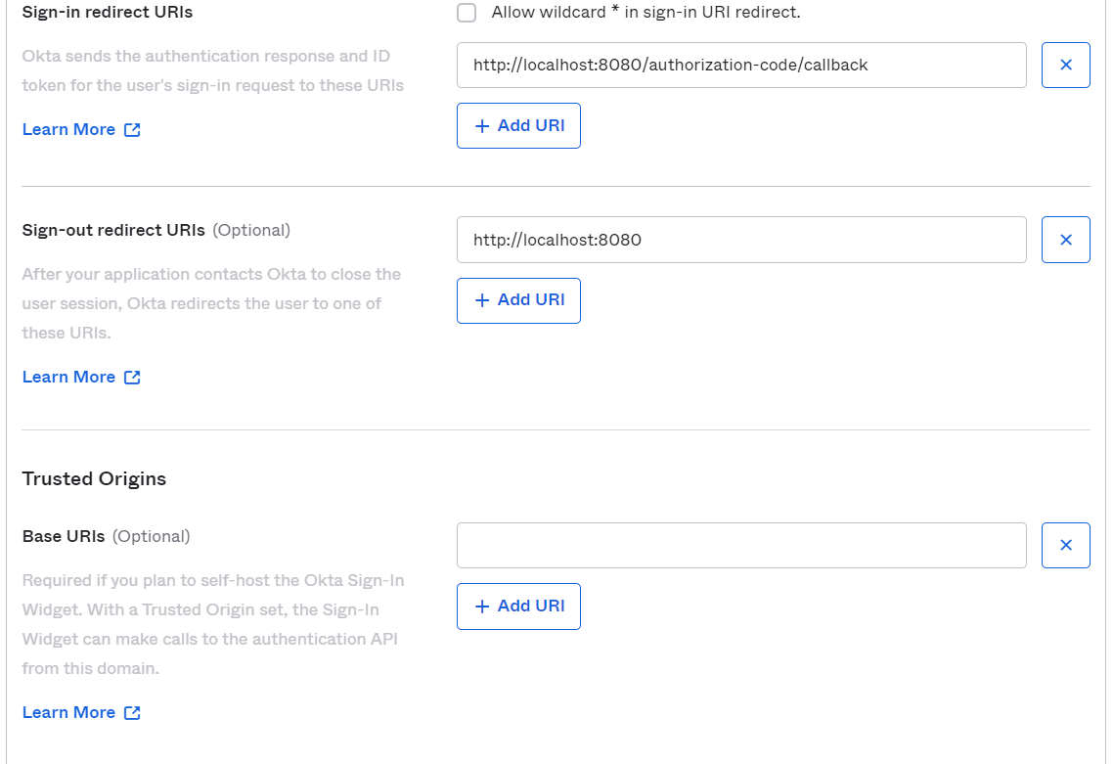

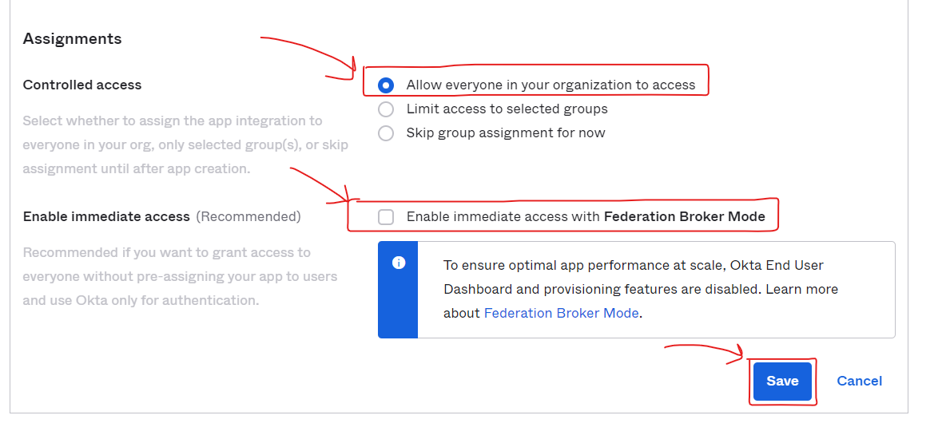

Click **Save** when finished.

As you can see from the screenshot above, we have set this client application for both **Client Credentials** as well as for **Authorization Code** OAuth 2.0 grants and have assigned this app to ‘**Everyone**'.

For this app, we are only going to implement the **Client Credentials** grant type.

**3.** You will land in the **General** tab of your application. From here, take a note of the **Client ID** and **Client Secret** generated. We will use them later.

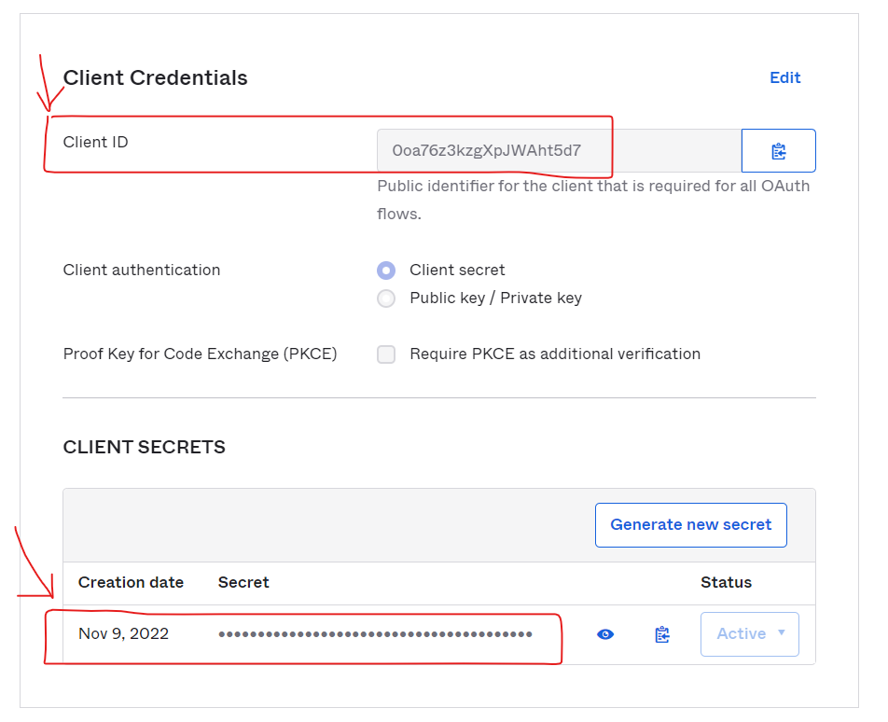

**4.** Add a **Custom Scope** for the **Web App.**

Go to **Security** → **API** → **Authorization Servers** → Click on **Default** → **Scopes**

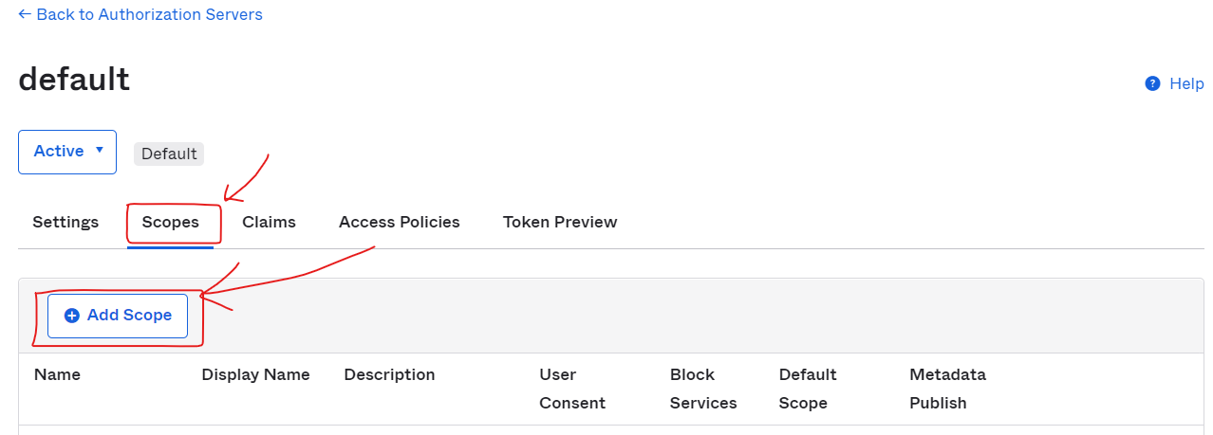

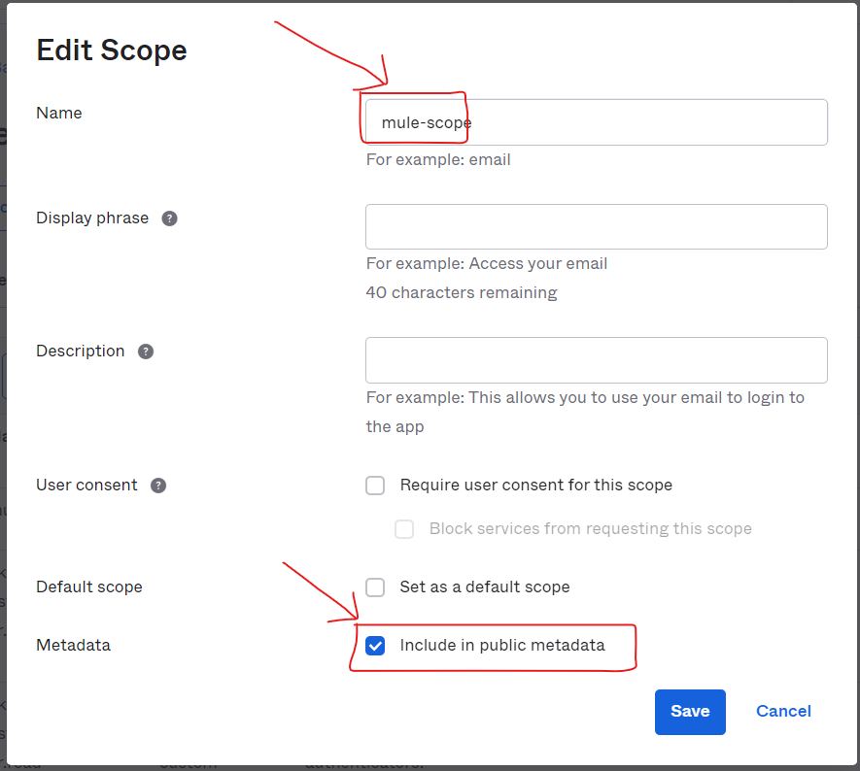

We'll need to use this **mule-scope** later on this exercise to properly retrieve an access token.

**5.** Now, similarly as with the **Web App**, we'll create a **Native App** in Okta. We'll name it **Native App**. 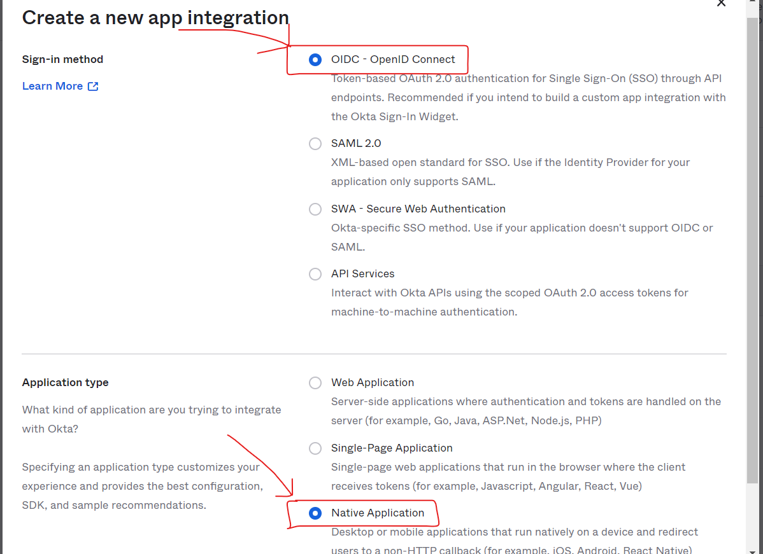

And select all the grant types (just in case we need them in the future). 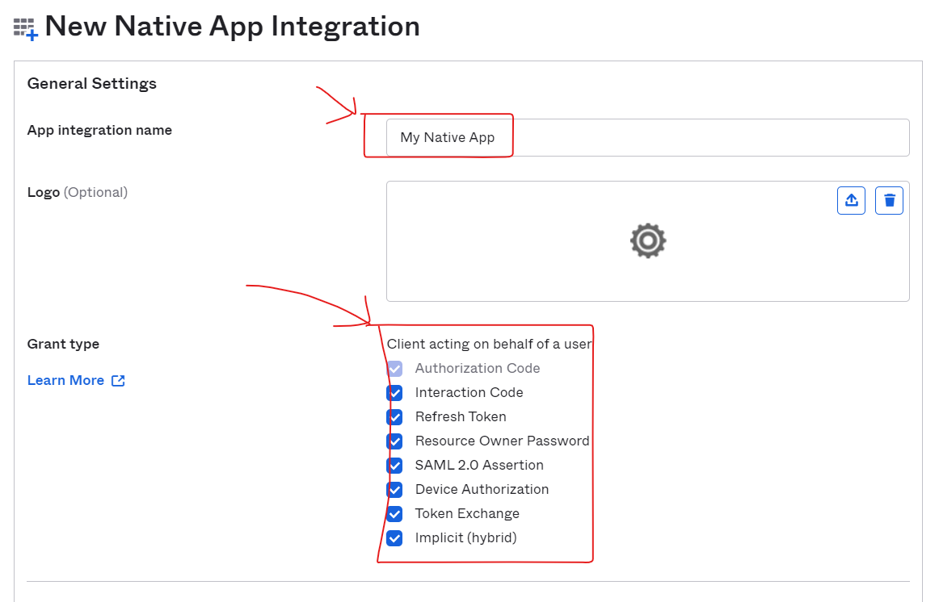

Click **Save** when finished. For this app, we are going to implement the other three grant types: **Authorization Code**, **Resource Owner Password** and **Implicit**.

Take a note of the Client ID and Client Secret from this app, we'll need them later.

**Note**: My recommendation is to keep track of *Client IDs*, *Client Secrets*, *URLs*, etc. And have them all in a text editor (like VS Code). It is easier to access them and we will definitely use them later.

**Note: for oauth native api make you uncheck Proof Key for Code Exchange (PKCE)**

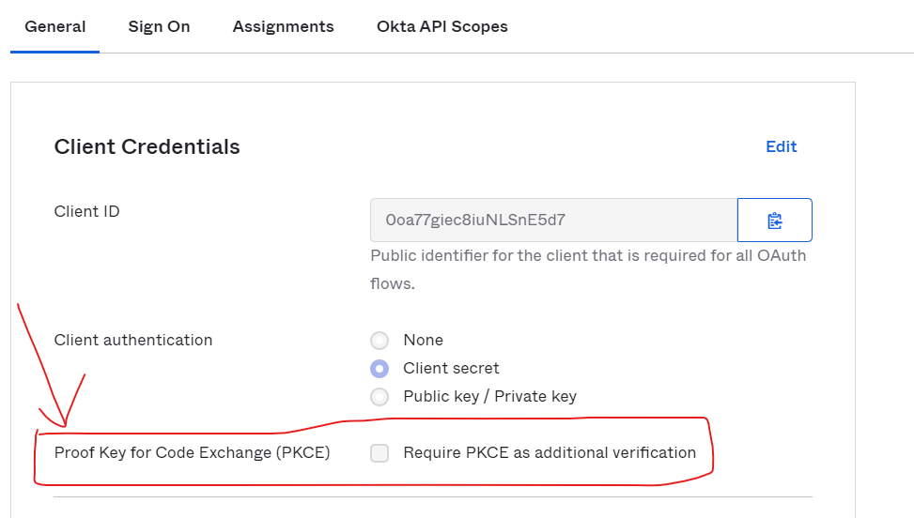

**6.** Add a **Callback URI** for the **Native App.**

Go to the *General Settings* of the **Native App** and from there Edit them.

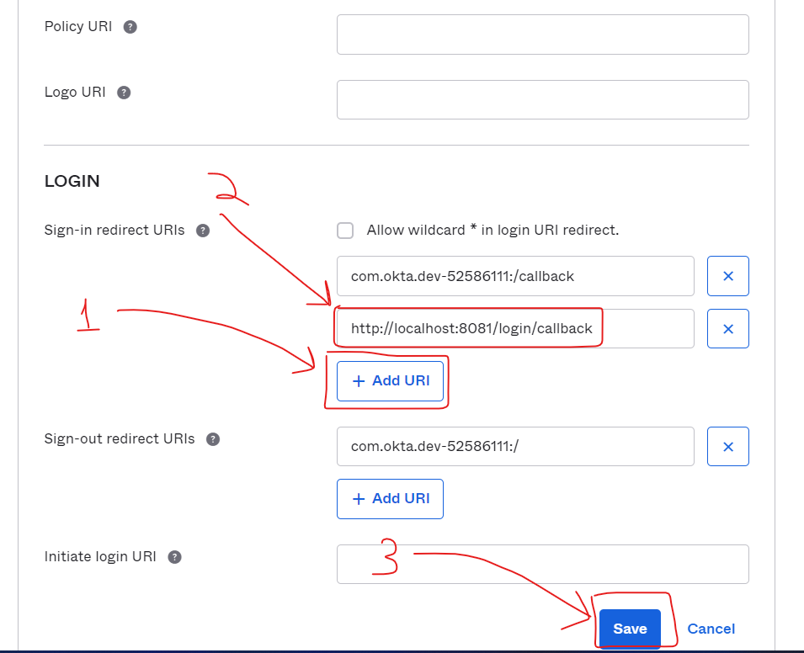

Add: [**http://localhost:8081/login/callback**](http://localhost:8081/login/callback)

Now, we're all set and ready to move on to the next step!

In this step, we are going to use a public API and then secure it by creating a proxy with Anypoint Platform. This will enforce the client to send a valid token to access the API.

We'll use this API to test the scenarios we develop later.

The API we'll be using is Random User API.

**1.** Check that the API is working properly from your browser:

https://randomuser.me/api/

It returns information about a random fake user, including gender, name, email, address, etc.

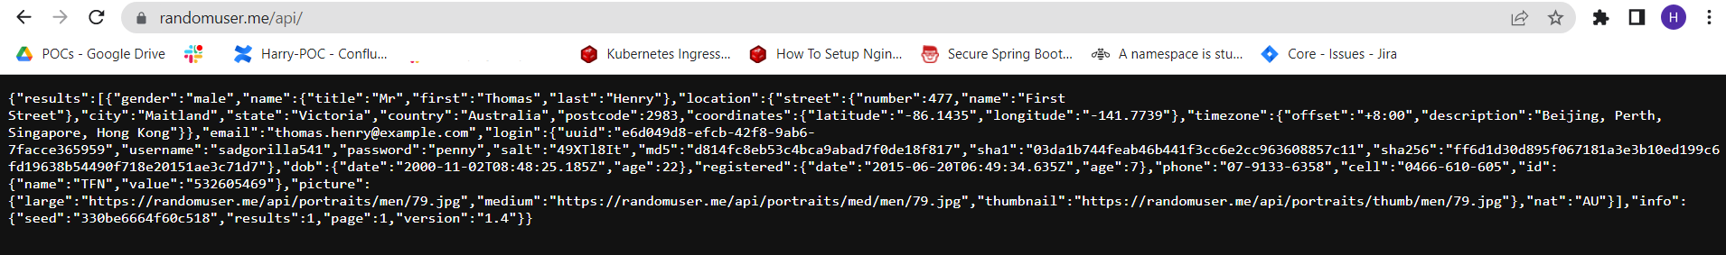

The important thing here is securing the API, not the API itself. So, let's secure it.

2. First, we are going to manage the Random User API from *API Manager*

*Go to* ***Anypoint Platform → Management Center→ API Manager****.*

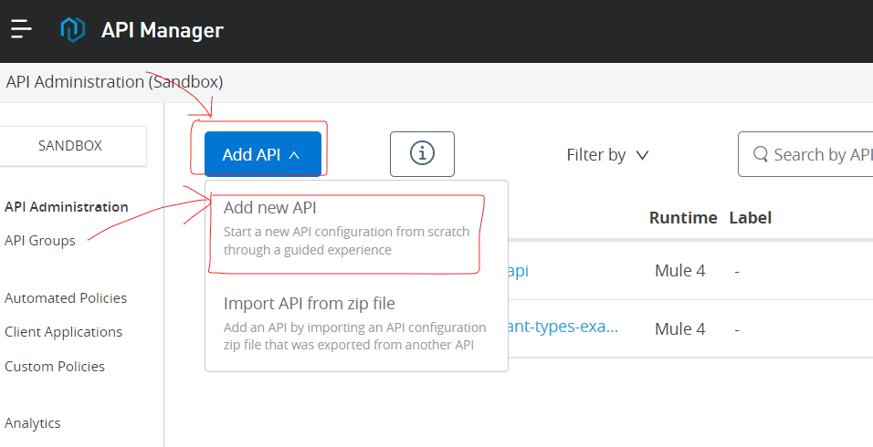

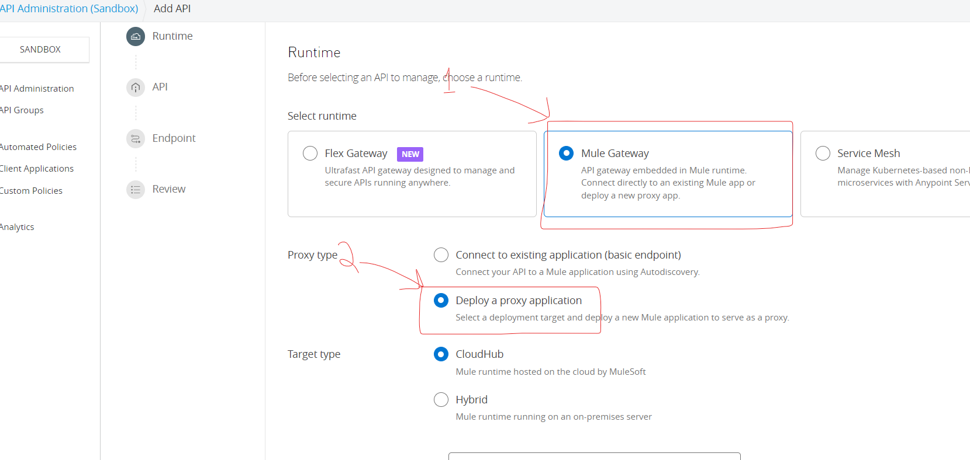

Select Mule Gateway and check proxy type as **Deploy a proxy Application**,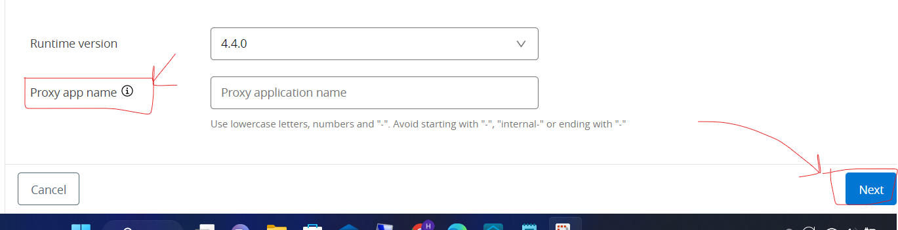

Provide proxy application name and click Next

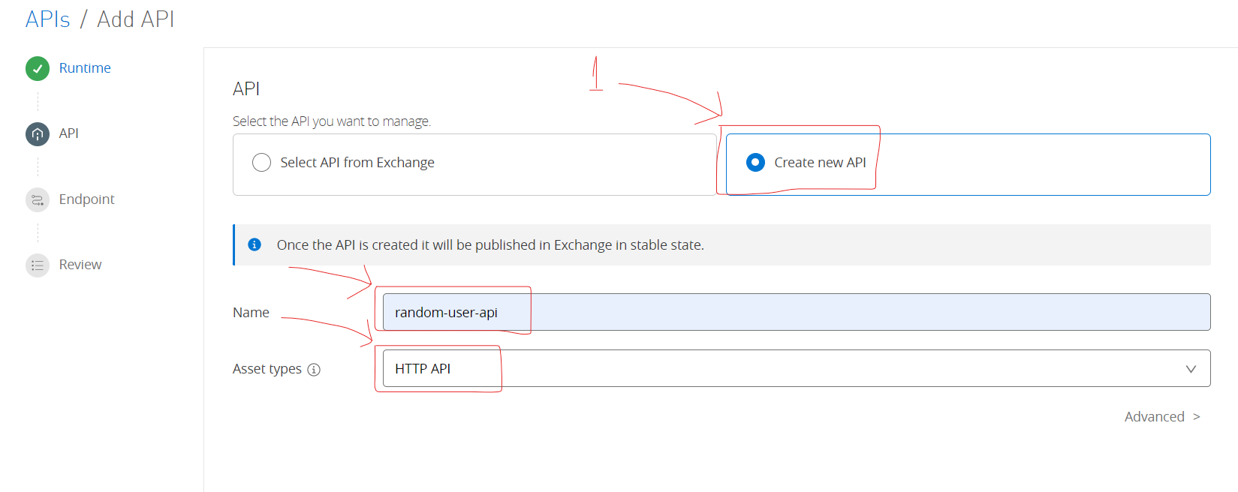

Click **Create new API** and provide Name and Asset type as **HTTP API**, click Next

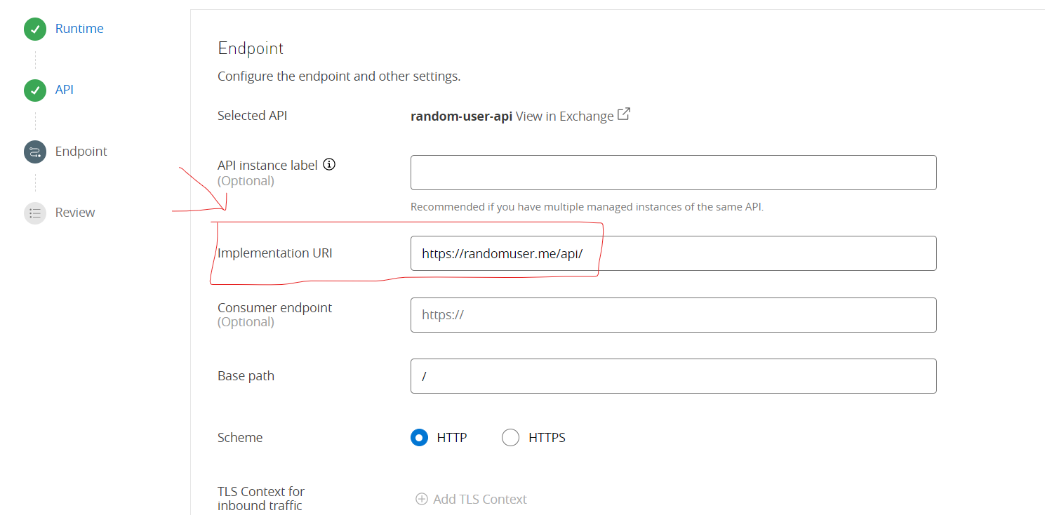

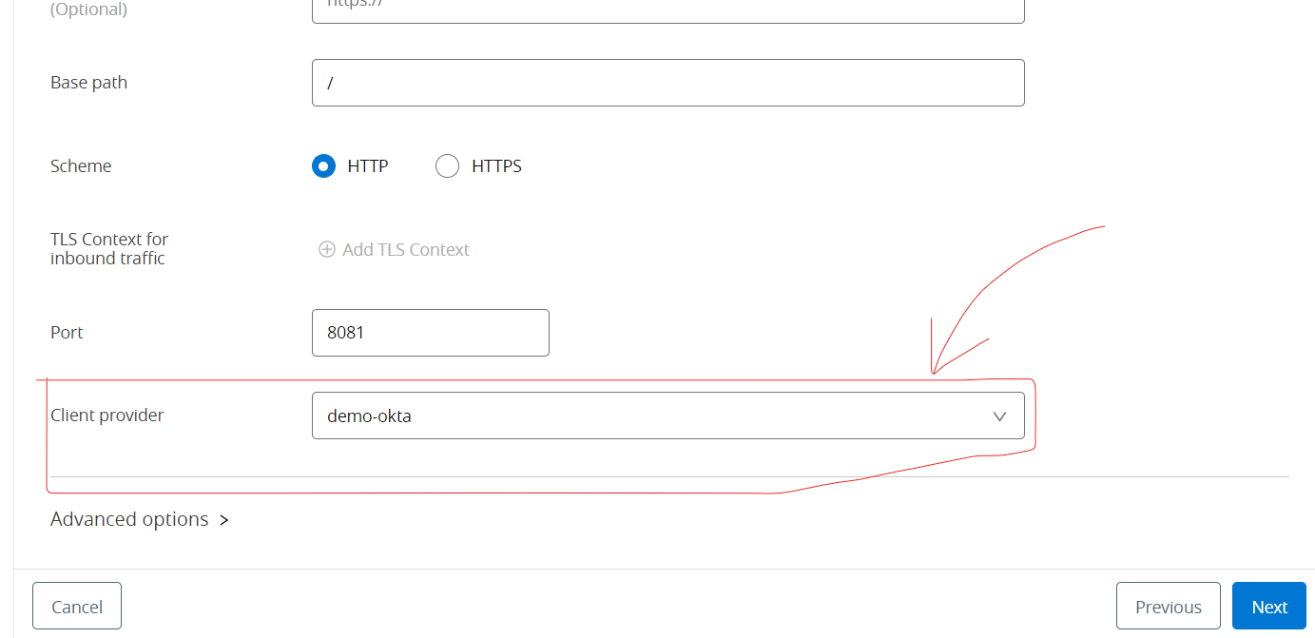

**WARNING:** In my case I'm using a Client Provider that I created before. You can check out this article regarding that <https://conflowence.atlassian.net/l/cp/NKAof9L7>

And then **Save and Deploy.** Then you will land on this page.

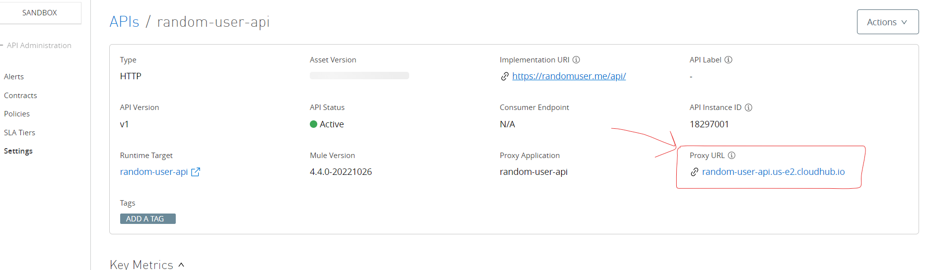

Wait until the deployment is successful.

**3.** Now that our Proxy has been successfully deployed to **CloudHub**, it's time to apply some *policy*.

Go to ***Policies → Apply New Policy → Click JWT Validation click Next***

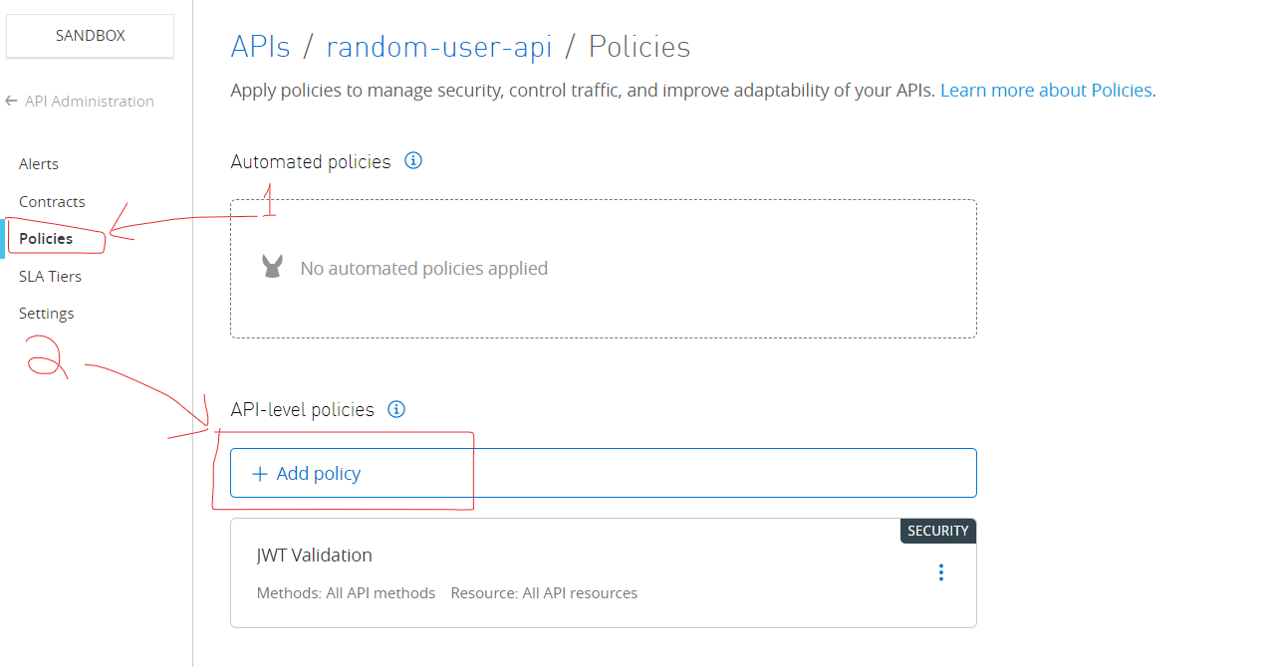

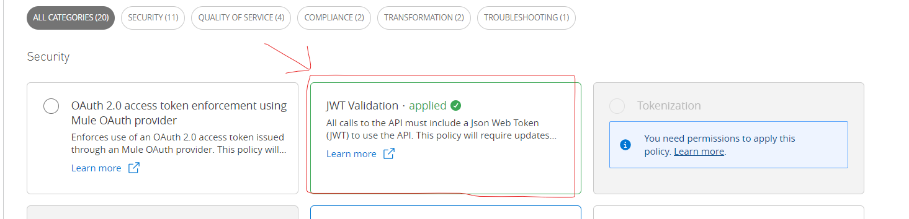

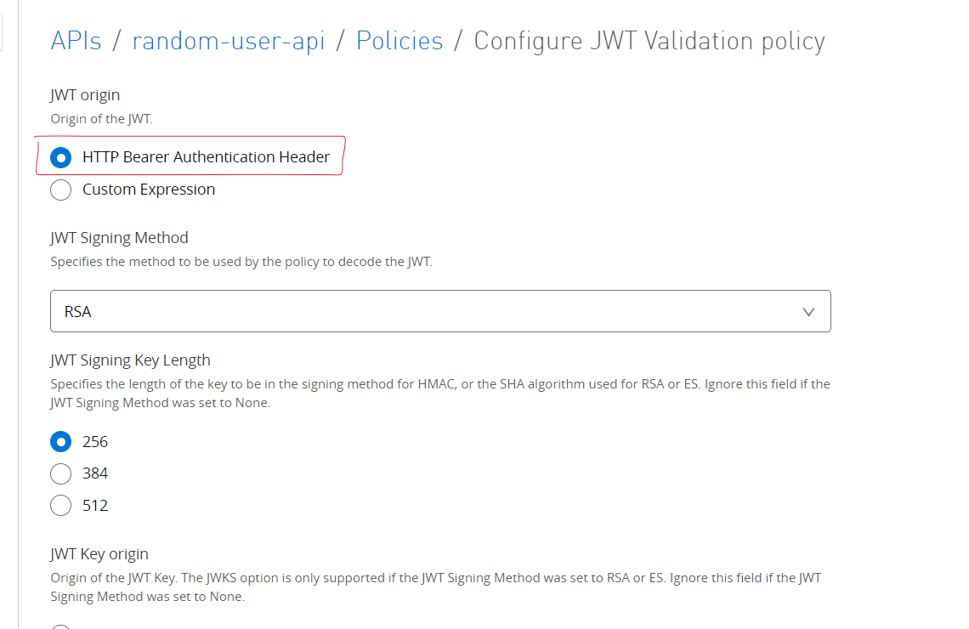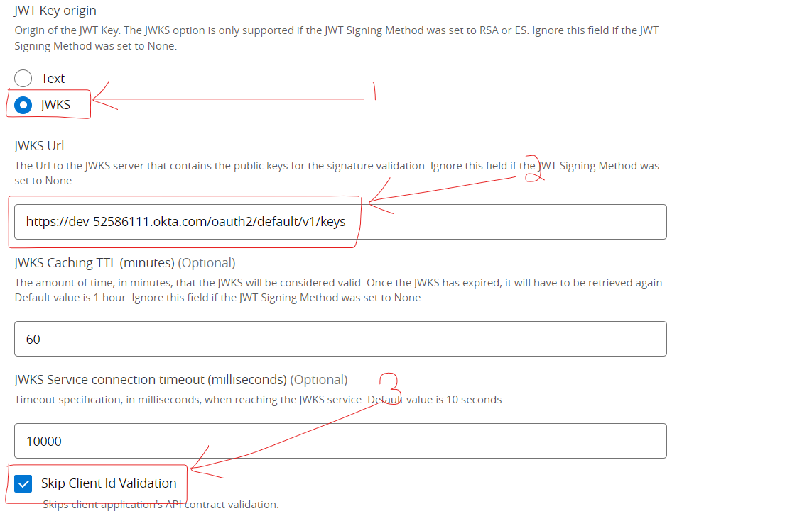

Check **JWKS** Then, in the JWKS Url add yours:

https://dev-********.okta.com/oauth2/default/v1/keys

**Note**: You can find this url in your Okta in the metadata of the *default* Auth Server. In my case the metadata URL is https://dev-********.okta.com/oauth2/default/.well-known/oauth-authorization-server (replacing the asterisks with your dev numbers).

Also, select **Skip Client ID Validation**.

The other default values leave them as they are and select **Apply**.

The policy configuration is ready.

**Note**: It may take a few minutes for the changes to be reflected in the Proxy, so wait a little before checking if the Policy is already working.

**4.** Now, from your browser or Postman you can try to call the API and you'll see that the **Token Enforcement Policy** is already working.

The Proxy URL in my case is:

Copy

http://random-user-api-ae.us-e2.cloudhub.io/

Use your URL and see what happens:

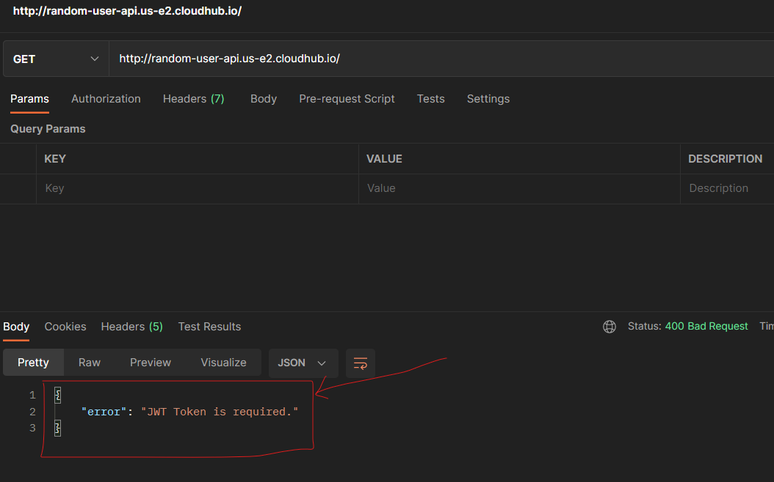

Our API is effectively secured!

Now, we are able to pass to the next step that is **getting a token** to access this Random User API.

First of all, in this step, we are going to prepare everything in Studio. Building the skeleton of the project, adding some modules from Exchange, adding some dependencies, etc. Mostly paving the way before implementing the different Grant Types.

If you want to skip this step you can download the **.jar** from the repository in **GitHub** where this **Codelab** is fully implemented.

Go to the folder docs and download the **jar** "oauth-template" and move on to **Step 6** to start implementing.

<https://github.com/Conflowence-POC/oauth-grant-types-examples.git>

If you want to learn how to prepare Studio, just follow these steps!

**1.** Open **Anypoint Studio** and create a new **Mule Project**.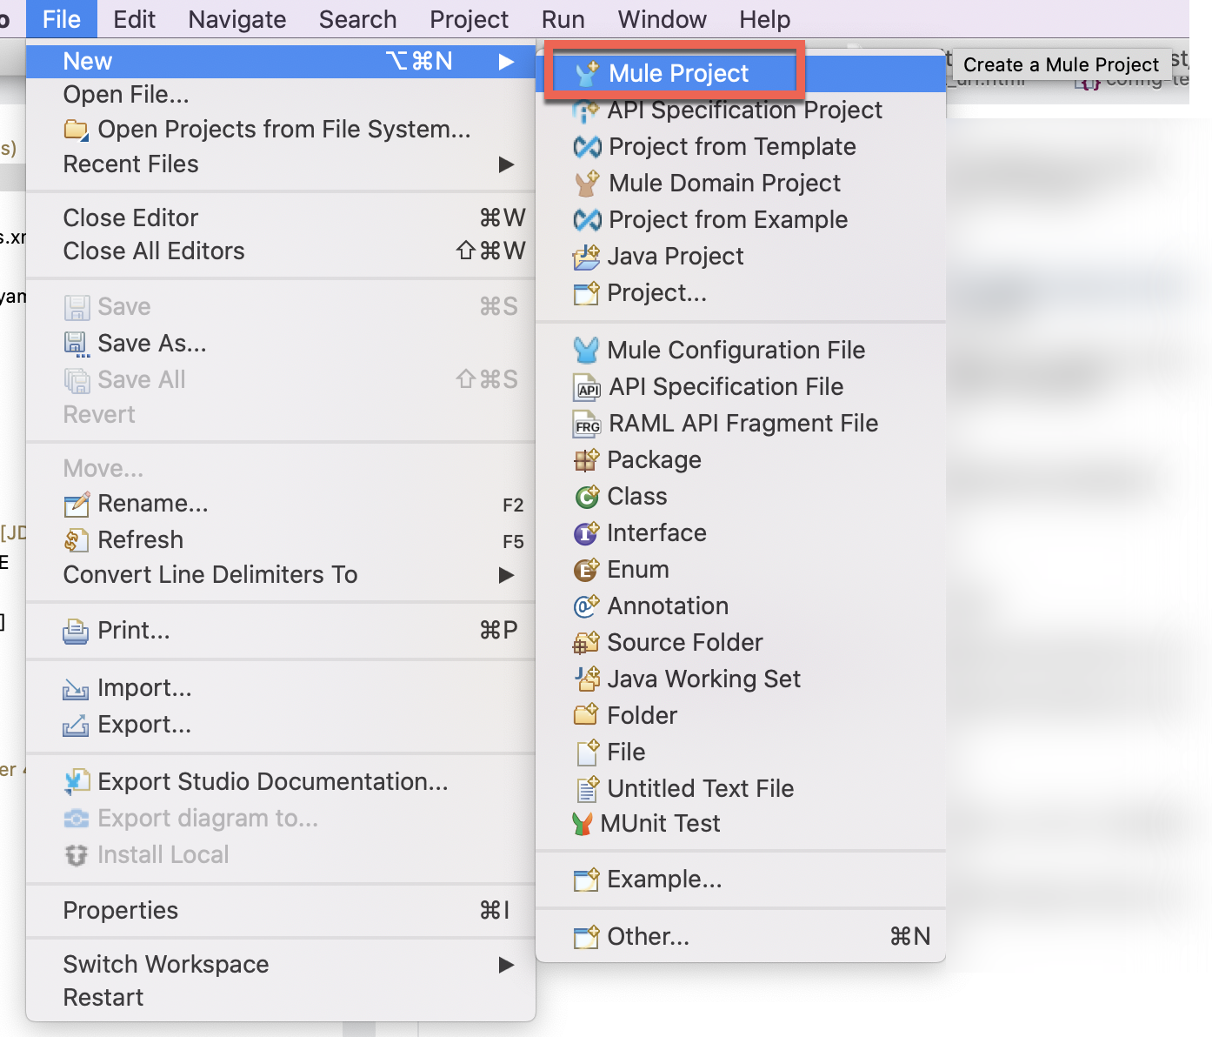

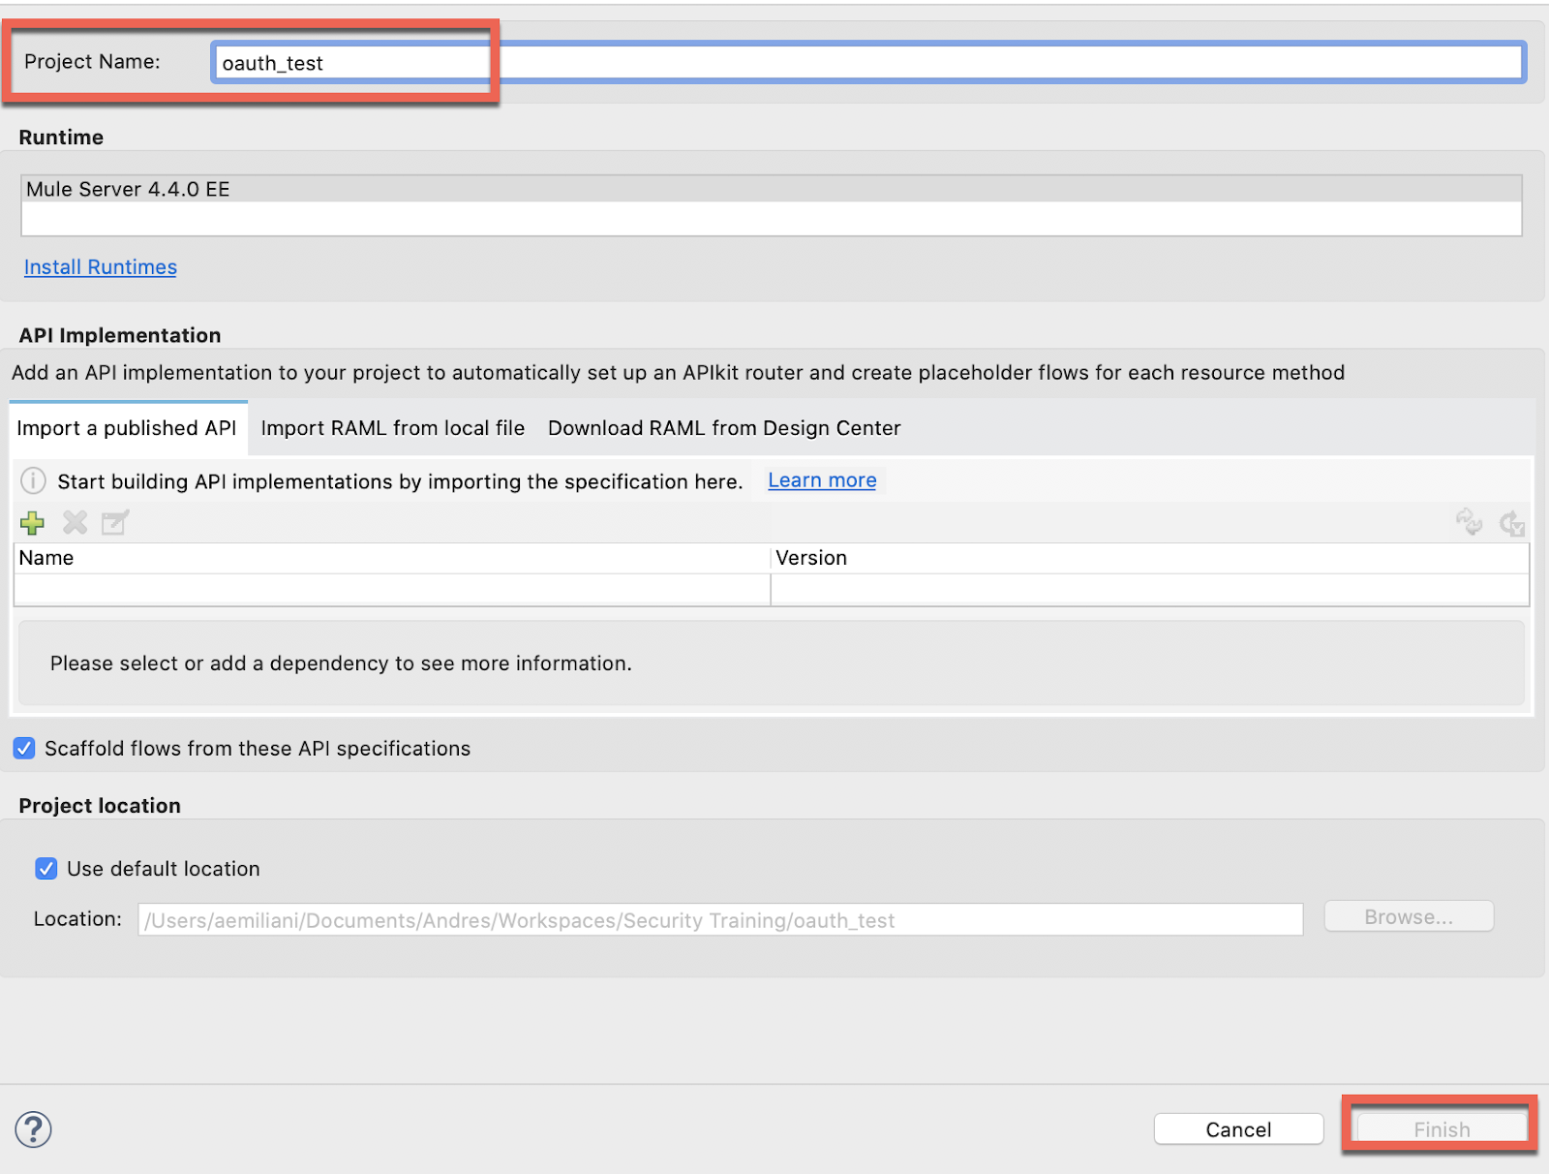

**2.** Import the **OAuth Module**:

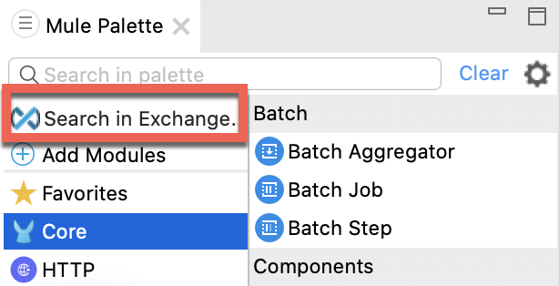

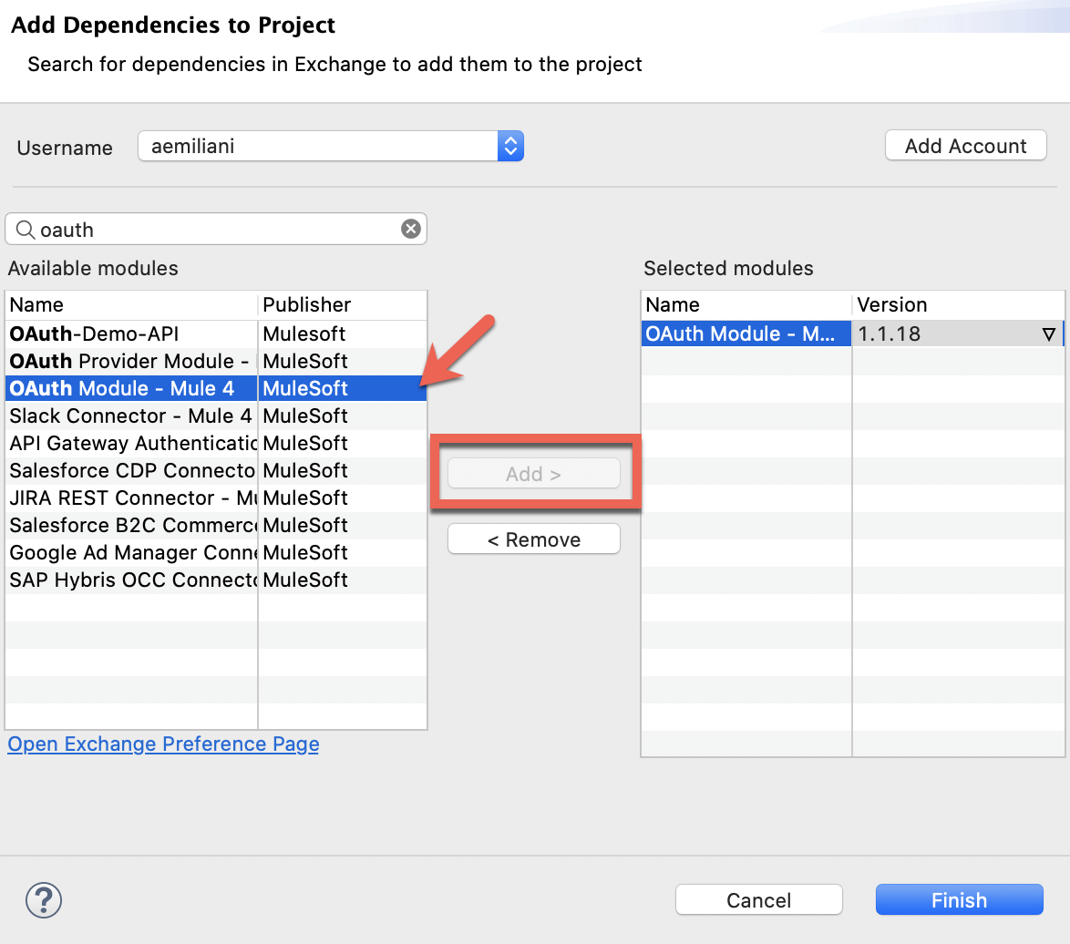

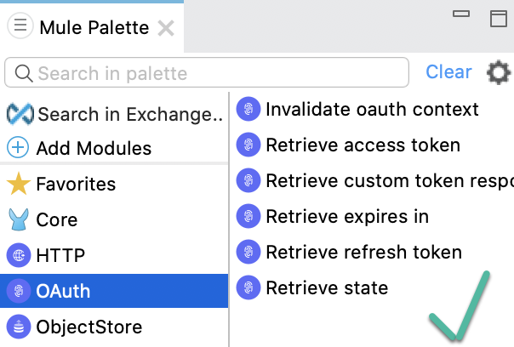

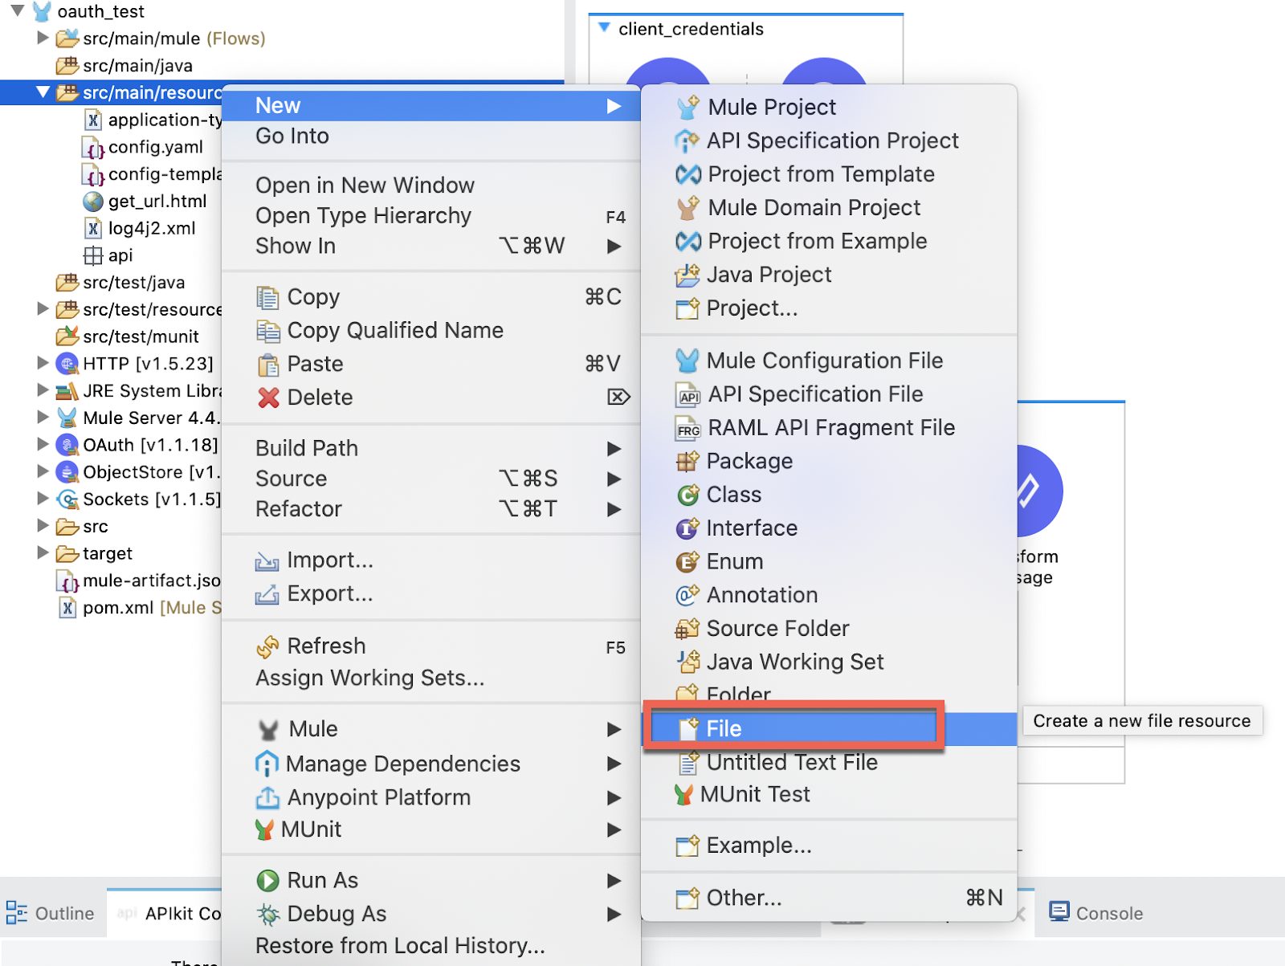

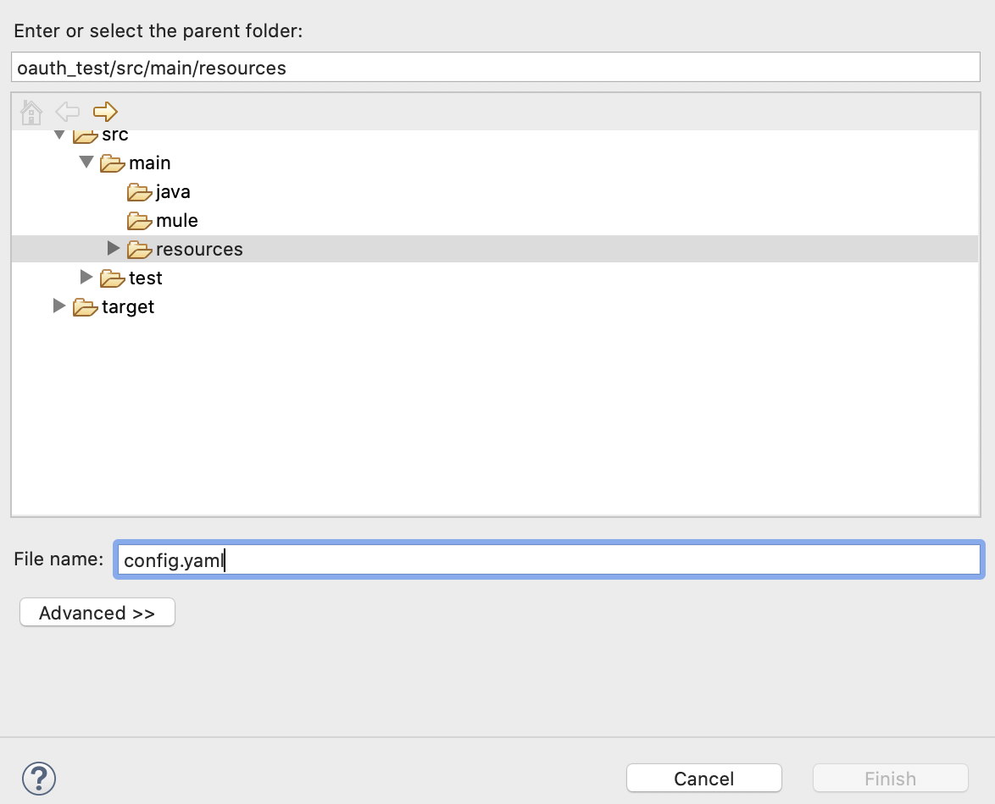

In this file copy this template:

native_app:

client_id: ""

client_secret: ""

redirect_uri: ""

scope: ""

auth_code:

login_callback_path: ""

external_callback_url: ""

local_auth_url: ""

implicit:

redirect_uri: ""

state: ""

web_app:

client_id: ""

client_secret: ""

client_credentials:

scope: ""

okta:

username: ""

password: ""

token_url: ""

token_path: ""

auth_url: ""

domain: ""

port: ""

api:

url: ""

static_resource:

path: ""

**4.** For getting the info to fill out the template, we need to go back to ***Okta***.

Go to **Security → API → Authorization Servers** and click on the **default** auth server.

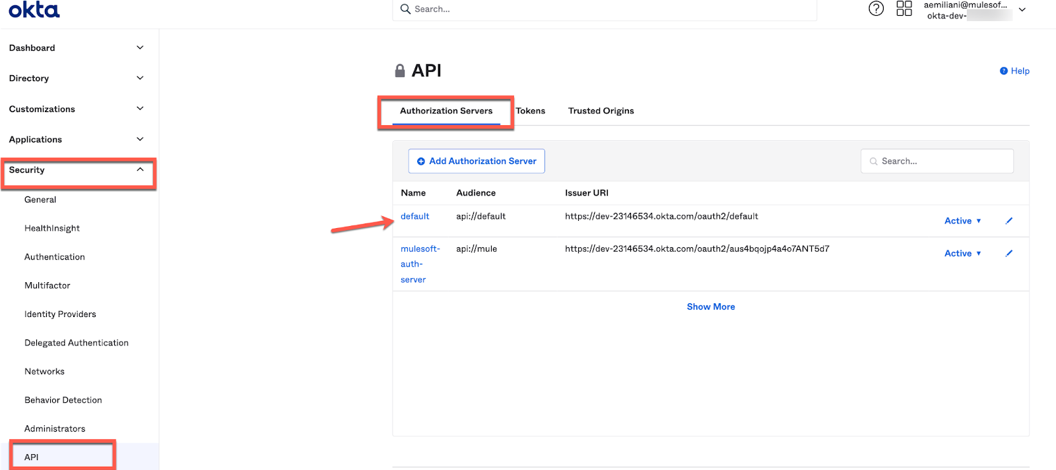

The link with the Metadata URL contains all the URLs you need. Click on it and take a note of the ones we need:

* *Authorization URL*
* *Token URL*

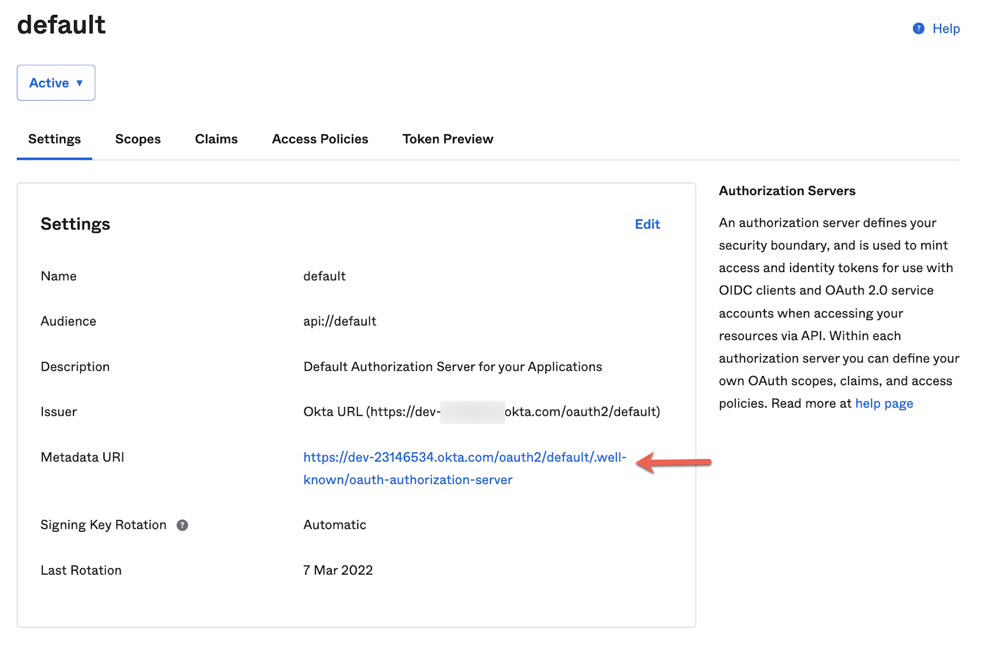

**5.** Fill it out with all the info requested that we'll use later in this exercise. It should look something like this:

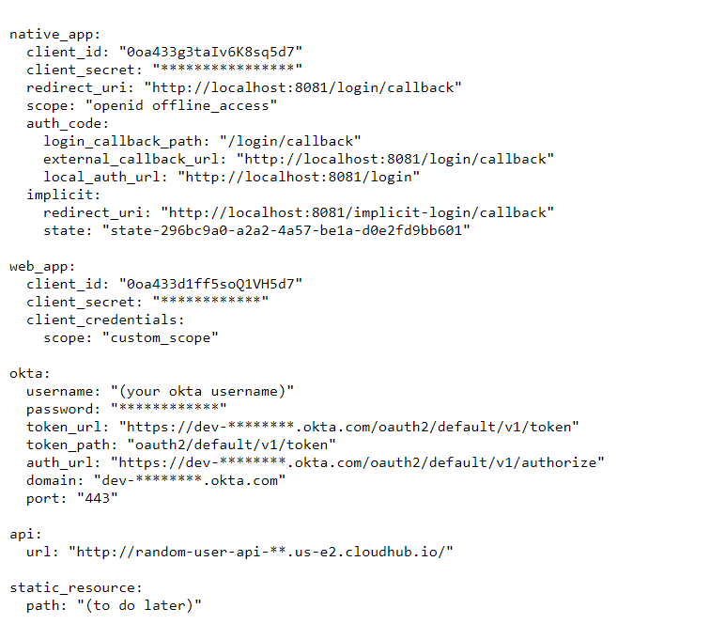

Or

native_app:

client_id: "0oa433g3taIv6K8sq5d7"

client_secret: "****************"

redirect_uri: "http://localhost:8081/login/callback"

scope: "openid offline_access"

auth_code:

login_callback_path: "/login/callback"

external_callback_url: "http://localhost:8081/login/callback"

local_auth_url: "http://localhost:8081/login"

implicit:

redirect_uri: "http://localhost:8081/implicit-login/callback"

state: "state-296bc9a0-a2a2-4a57-be1a-d0e2fd9bb601"

web_app:

client_id: "0oa433d1ff5soQ1VH5d7"

client_secret: "************"

client_credentials:

scope: "custom_scope"

okta:

username: "(your okta username)"

password: "************"

token_url: "https://dev-********.okta.com/oauth2/default/v1/token"

token_path: "oauth2/default/v1/token"

auth_url: "https://dev-********.okta.com/oauth2/default/v1/authorize"

domain: "dev-********.okta.com"

port: "443"

api:

url: "http://random-user-api-**.us-e2.cloudhub.io/"

static_resource:

path: "(to do later)"

**Note 1**: Replace with your info the ****.

**Note 2**: The ***static_resource*** part leave it blank right now. We will come back to this later.

**6.** Add a **Global Configuration Element** for the **config.yaml**.

From the **oauth_test.xml** go to **Global Elements** and **Create** a new one:

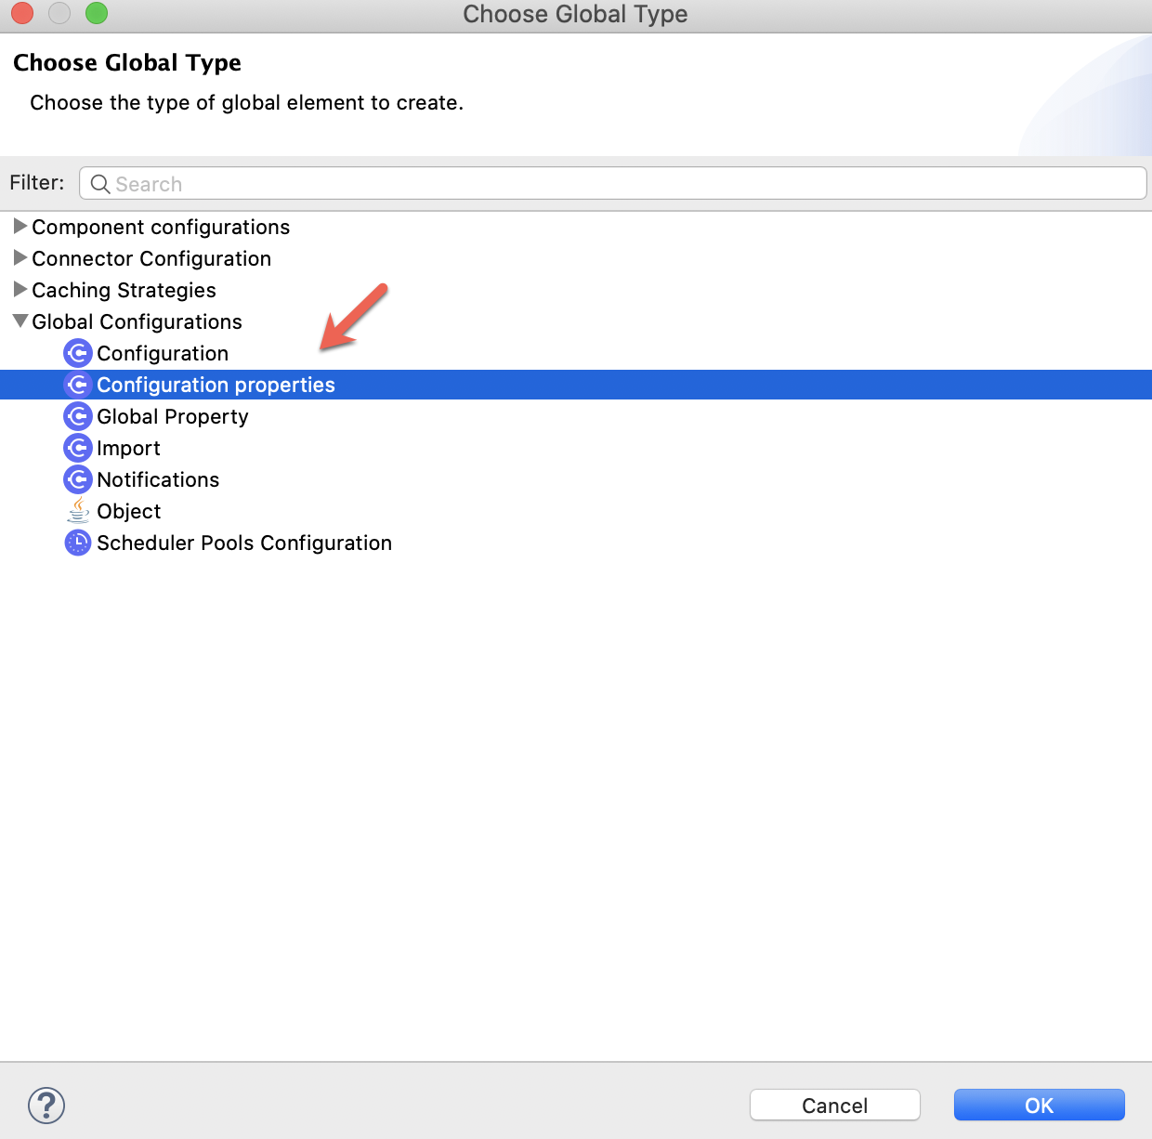

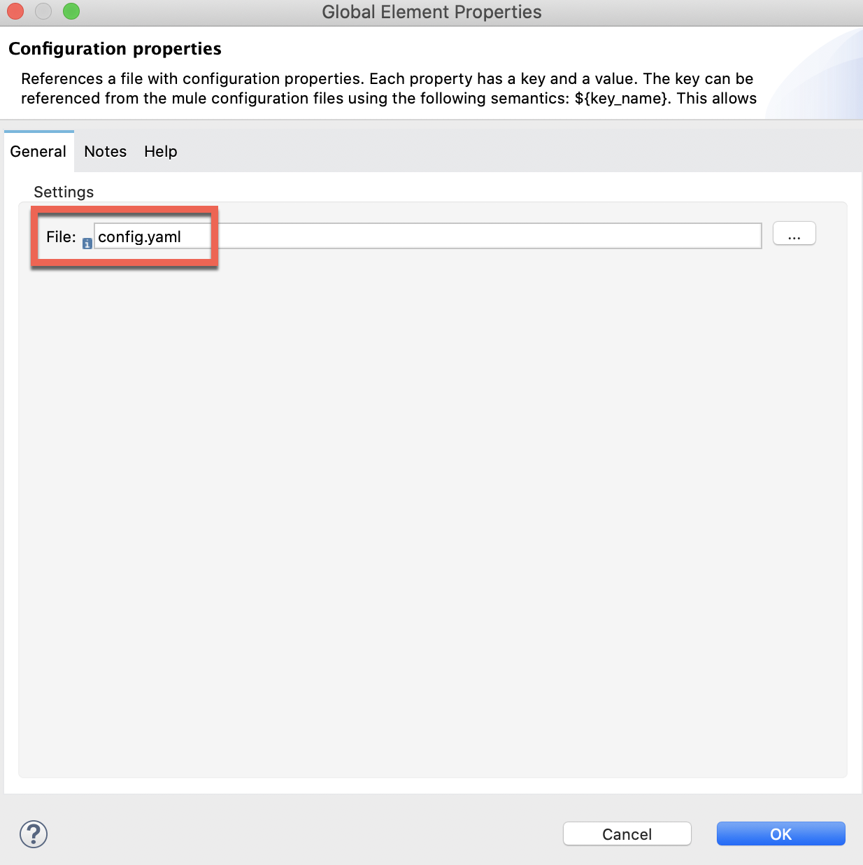

**7.** Now, we are going to create an **Object Store** to keep record of the **Tokens** we will be obtaining.

This is how the flow will look like:

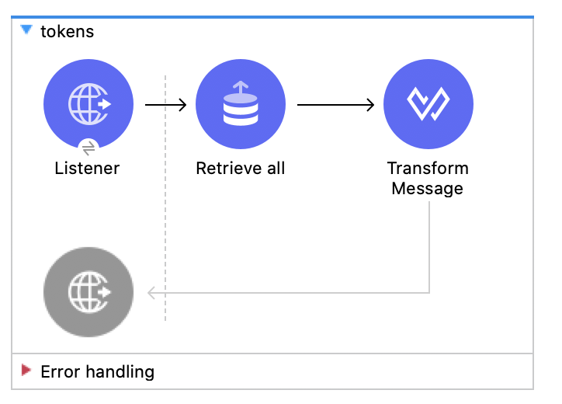

The **Listener** is configured with the ***default*** global configuration (*HTTP_Listener_config*) and the path will be /tokens.

For the **Retrieve all** operation we need to import the **ObjectStore** connector from Exchange:

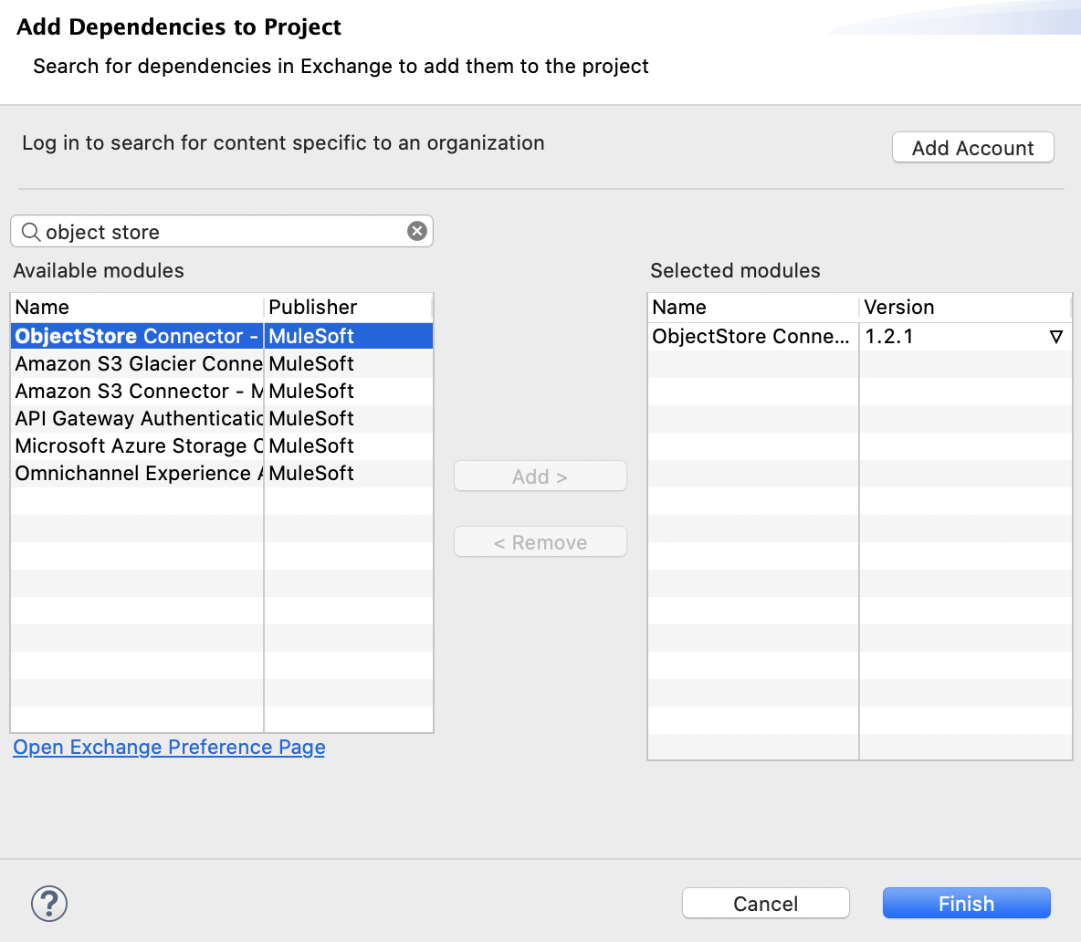

And, in the **Retrieve all** operation, configure the **Object Store** by creating a new **Token Manager** (to save and manage all tokens) called **Tokens**:

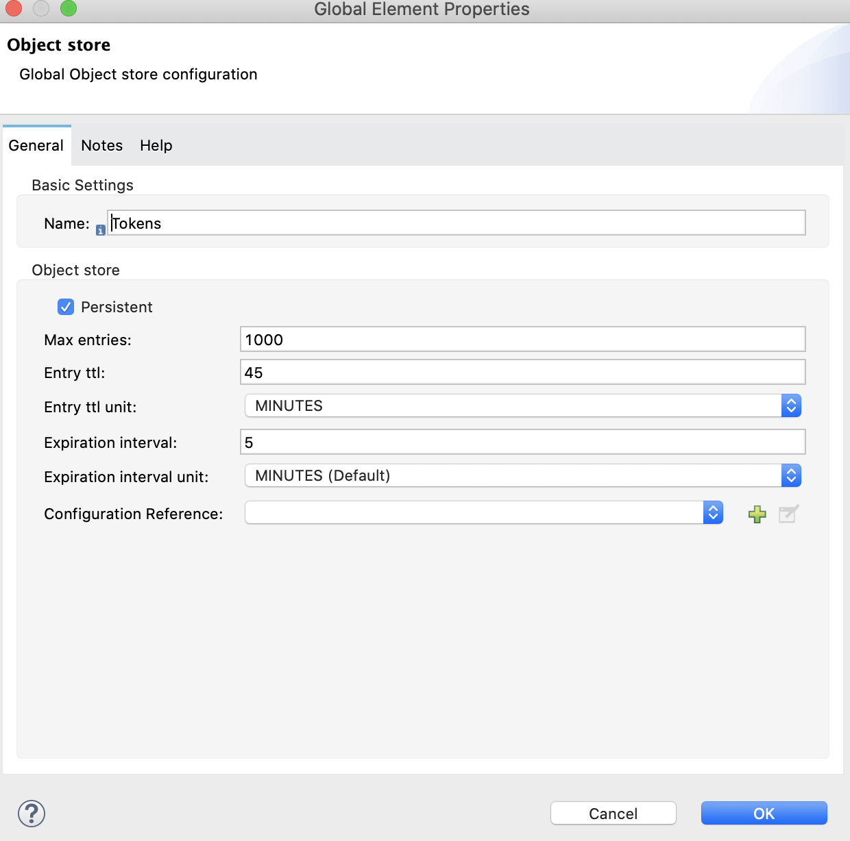

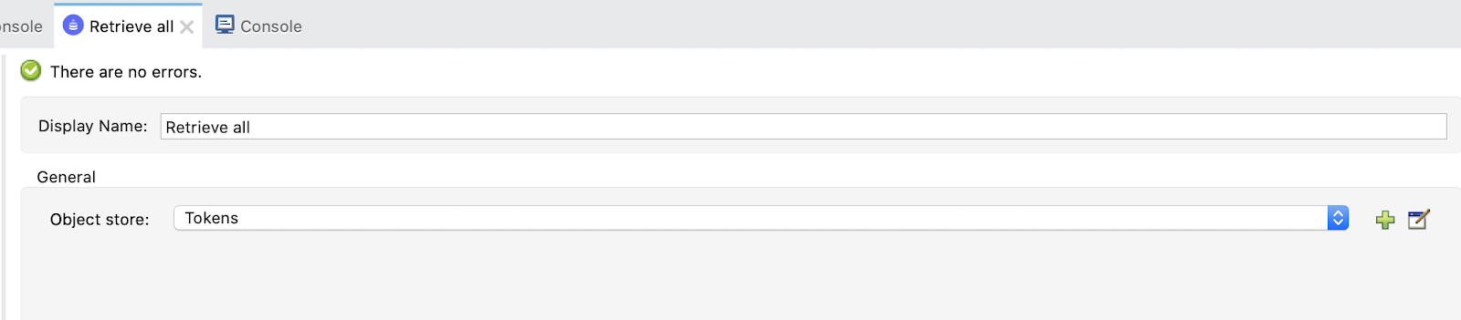

Finally, **Transform** data into JSON:

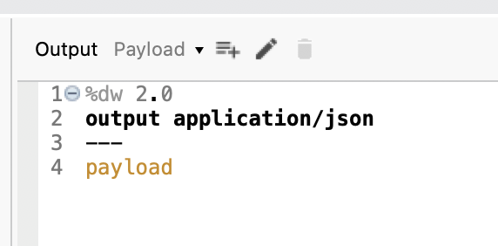

**8.** Finally, we are going to create a flow to invalidate the stored tokens. To later on, show properly how each Grant Type works, without skipping the part of getting an access token.

Let's create a flow and name it invalidate:

It would look like this:

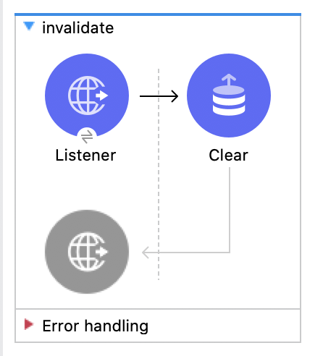

The **Listener** would have the global *HTTP_Listener_config* and the path will be /invalidate.

The **Clear** operation will have an Object Store Tokens:

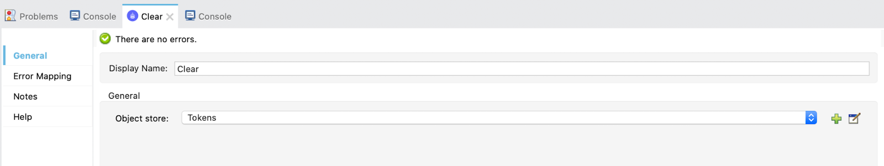

Studio is all set right now. We are ready to implement the different flows for the four **Grant Types** we are learning!

The first grant type we are going to implement is **Client Credentials**. We are using the Web App and our Random User API.

**1.** Create a new flow and name it **client_credentials**.

This will be the final flow:

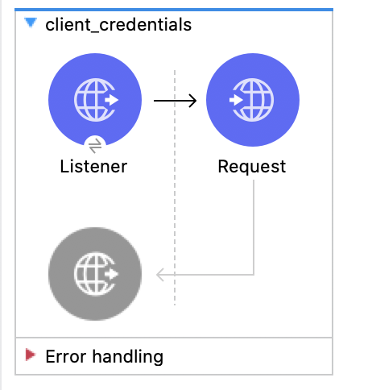

**2.** So, first drag a **Listener** and select the default global configuration (*HTTP_Listener_config*) and set the path to /client_credentials. Just like this:

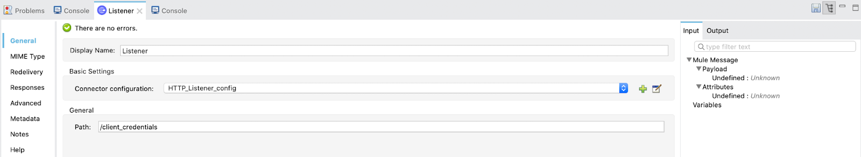

**3.** Drag a **Request** and configure it.

**Note**: The Request configuration will inherit some features from the **OAuth** module we've just imported. So, the **client credentials** and **authorization code** flows can be configured almost automatically.

Configure the *global configuration* for the HTTP Request:

(these are the values you'll have to copy and paste)

Copy

Name: HTTP_Request_configuration-Client_Credentials

Client id: ${web_app.client_id}

Client secret: ${web_app.client_secret}

Scopes: ${web_app.client_credentials.scope}

Token url: ${okta.token_url}

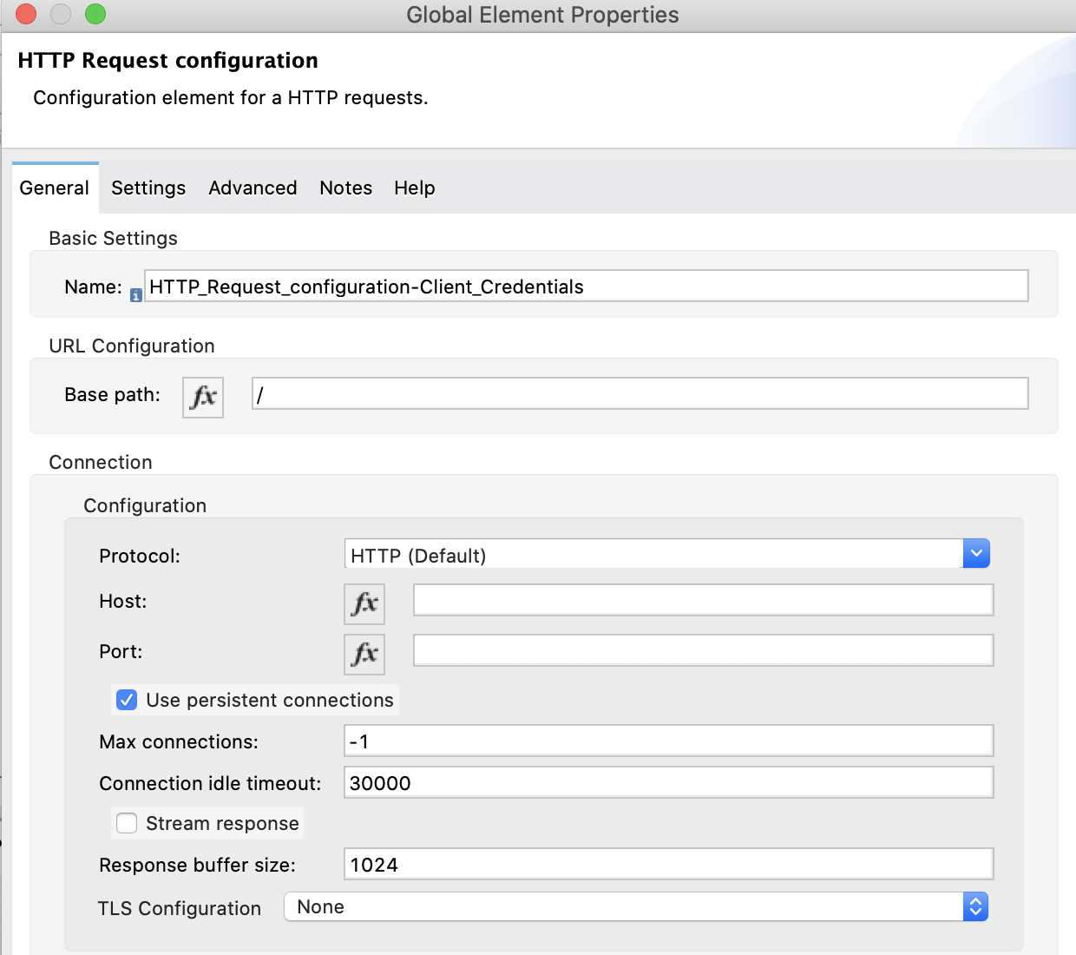

Select **Tokens** for the **Object Store** configuration:

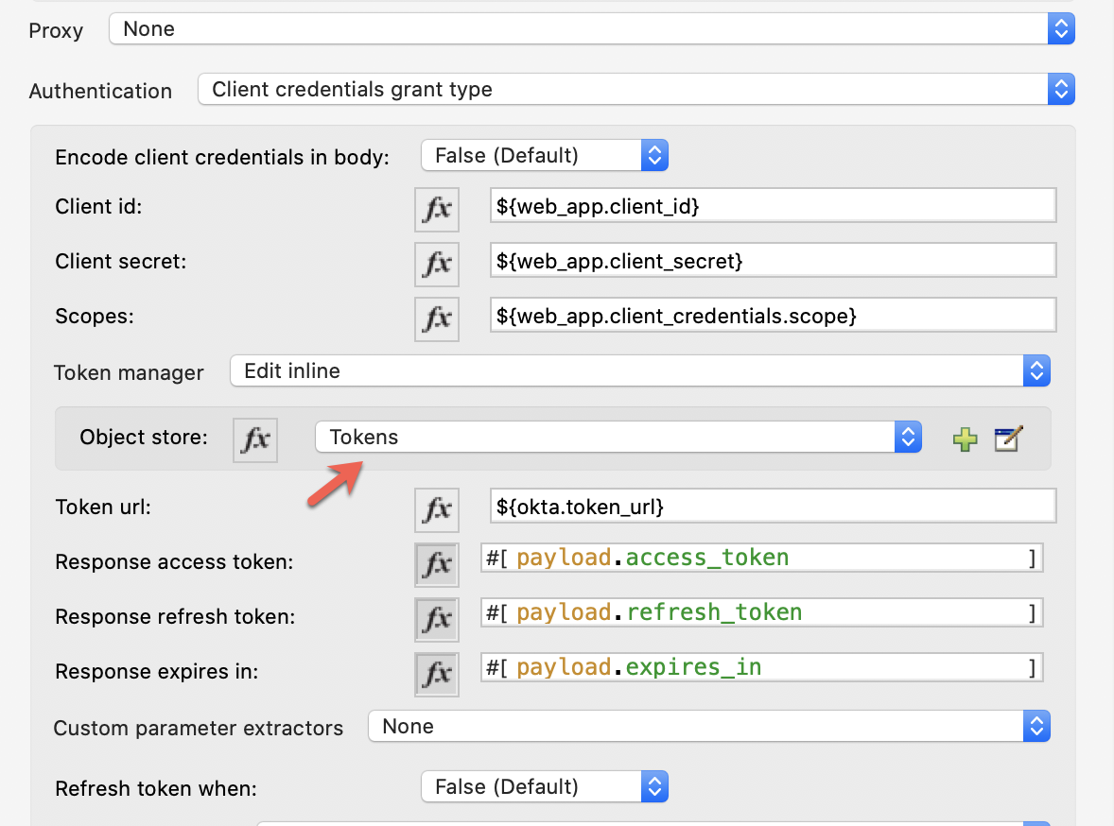

And finish the *Request configuration*:

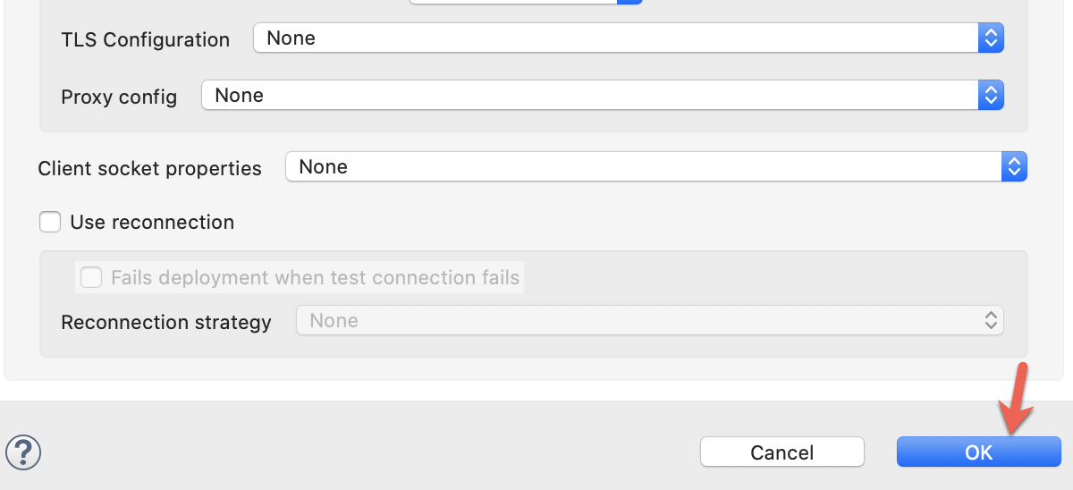

**4.** The other part of the **Request** configuration will be the following:

URL: ${api.url}

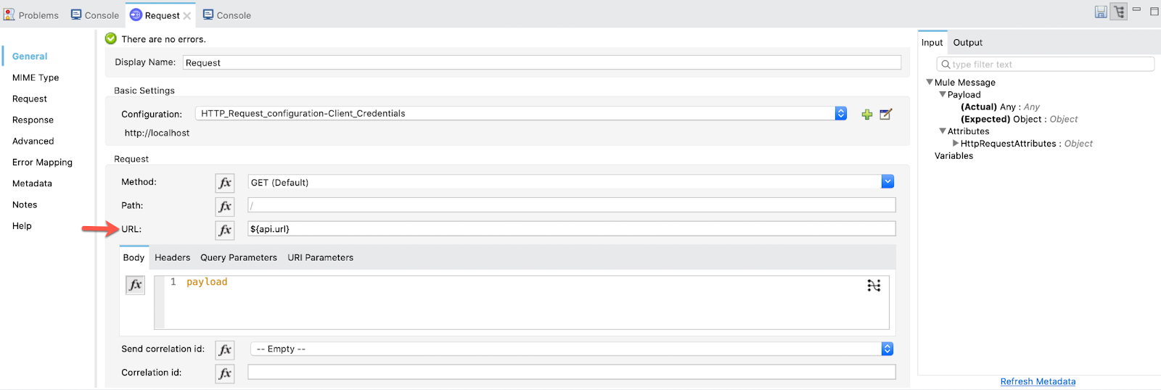

**5.** Now, we are able to **test** this first flow and see what happens...

Go to **Postman** (or any other application that allows the testing of web APIs, like ARC) and make a **GET** request:

<http://localhost:8081/client_credentials> (you can find postman api json file under src/test/resources of the github project)

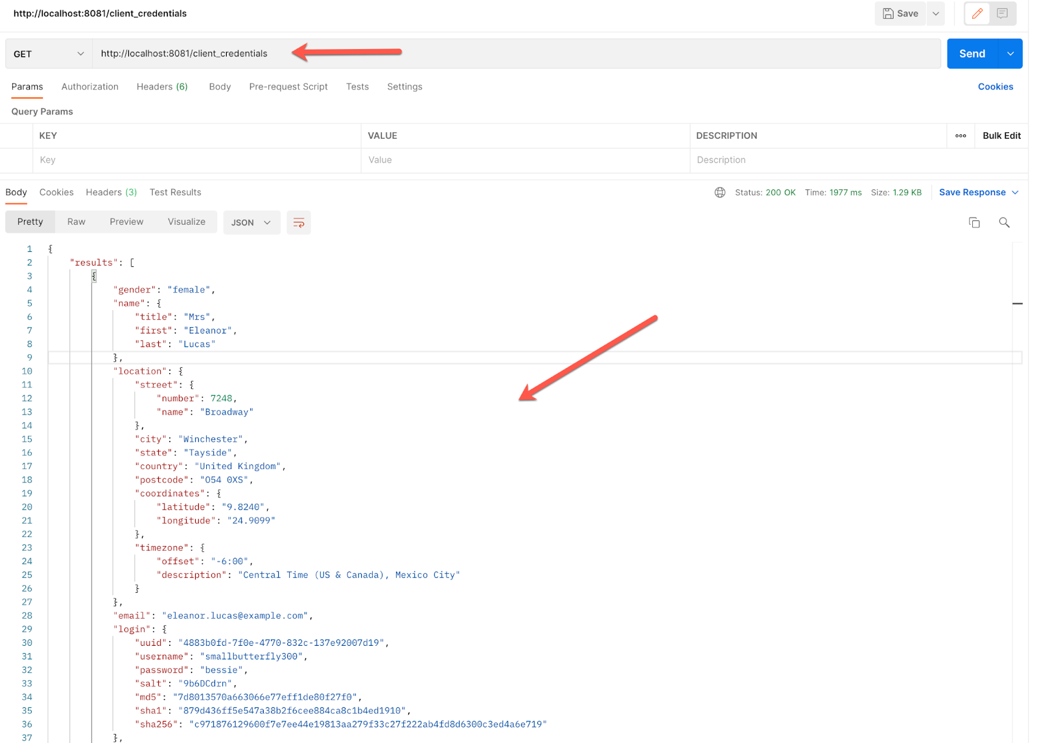

The response is right there!

So far so good. Let's move on to the next *Grant Type:* Authorization Code!

For this Grant Type we are going to use the Native App created in **Okta**.

**1.** Create a new flow and name it auth_code:

At the end it will look like this:

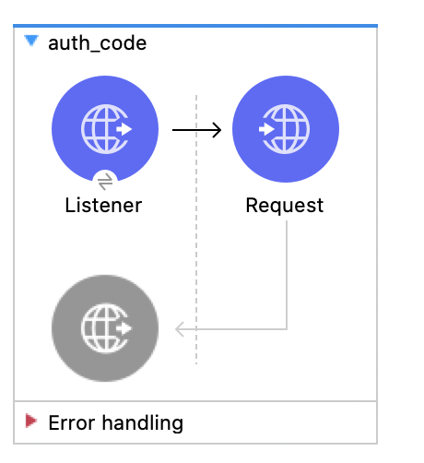

**2.** Drag a **Listener**, choose the HTTP_Listener_config and set the path to /auth_code.

Then drag a **Request** and configure it:

Name: HTTP_Request_configuration-Auth_Code

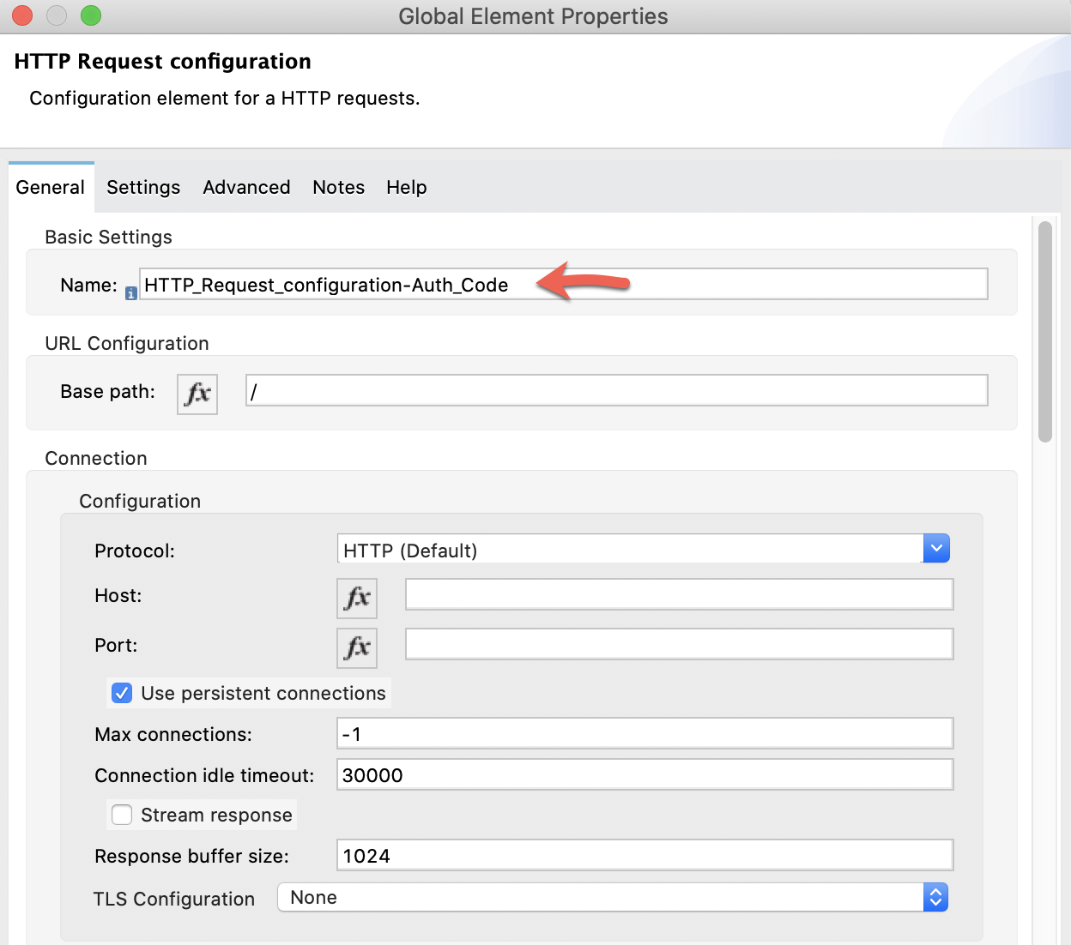

Authentication: Authorization code grant type

Local callback config: HTTP_Listener_config

Local callback config path: ${native_app.auth_code.login_callback_path}

External callback url: ${native_app.auth_code.external_callback_url}

Local authorization url: ${native_app.auth_code.local_auth_url}

Authorization url: ${okta.auth_url}

Custom parameters: Edit inline (and add some state)

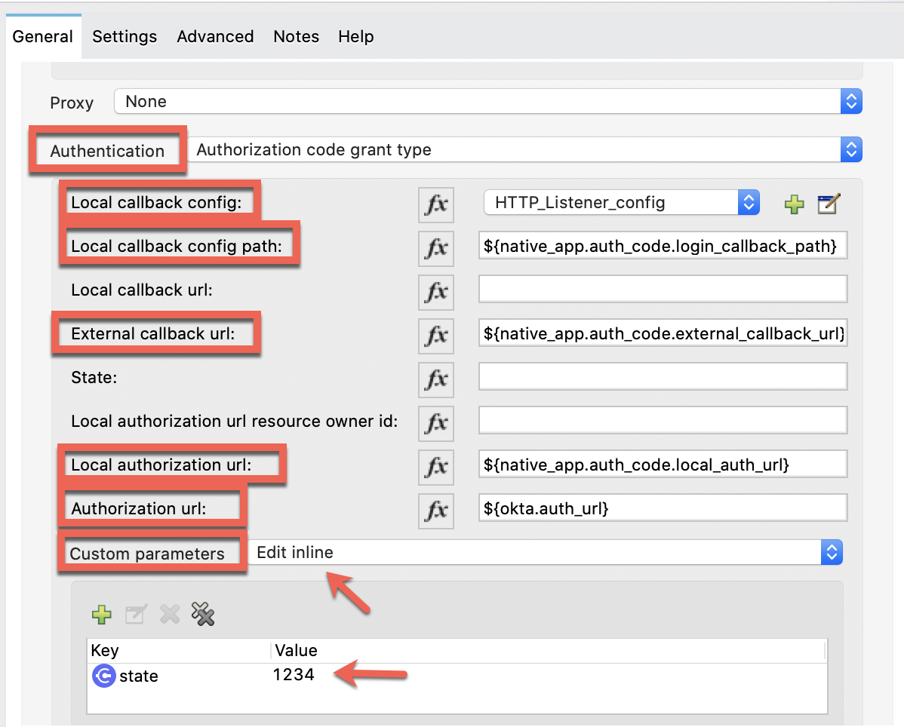

Client id: ${native_app.client_id}

Client secret: ${native_app.client_secret}

Scopes: ${native_app.scope}

Token Manager: Same as in Client Credentials. Add "Tokens" to the Object Store.

Token url: ${okta.token_url}

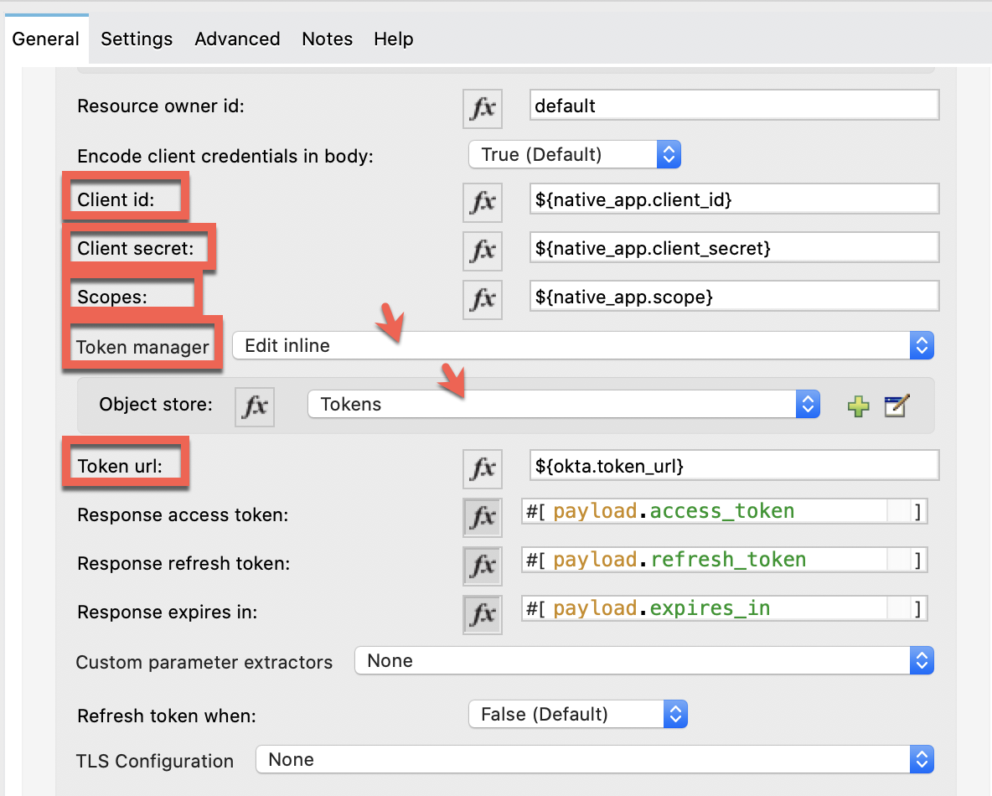

And finish the configuration:

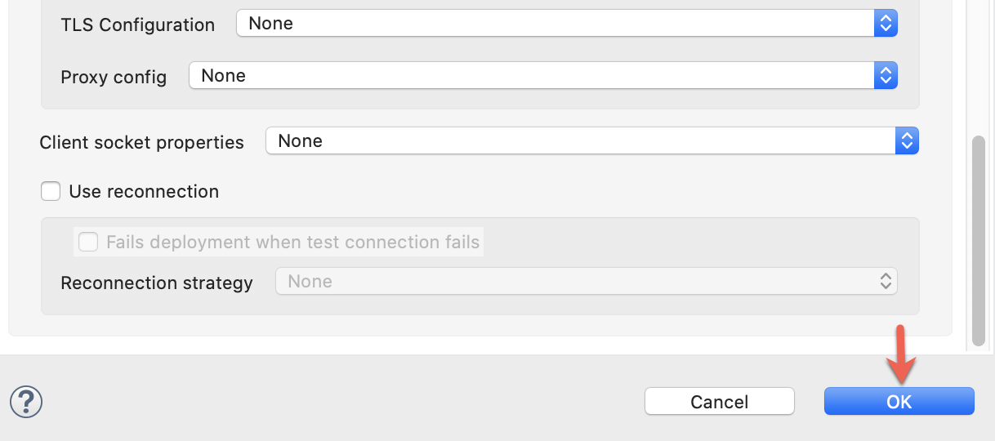

**3.** Add the API *URL* to the **Request**.

URL: ${api.url}

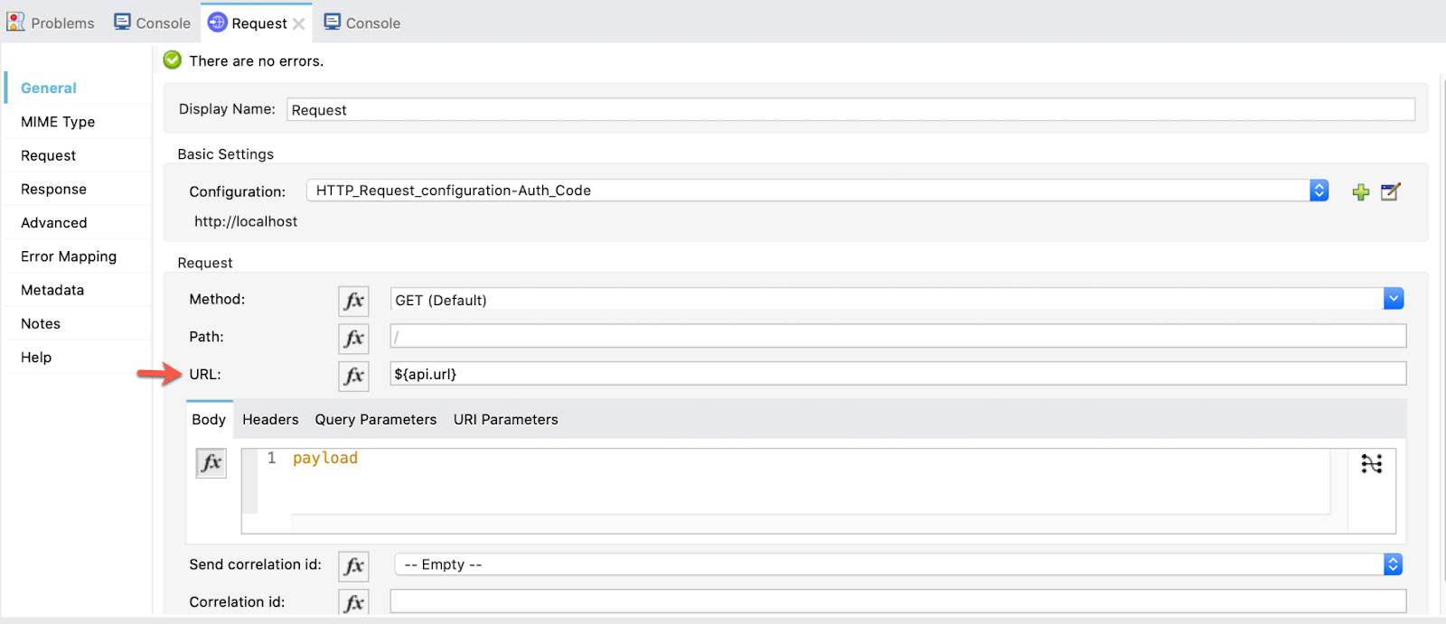

We are ready to test this Grant Type!

**4.** Before testing the auth_code flow we need to point out something.

The flow tokens is collecting the access tokens we are creating and they will be stored until we clean or invalidate them.

The purpose of having the tokens stored is to automate as much as possible our application. But, for the purpose of showing the functionality of the **Auth Code Grant Type** (and the next ones), we already created a flow to invalidate the stored tokens. So that when we use this grant type we don't skip steps.

So, first, go to Postman and send a GET request to:

<http://localhost:8081/invalidate> (you can find this endpoint in postman api file in src/test/resources of the github project)

The response will be empty but what it is really doing is cleaning up the stored tokens.

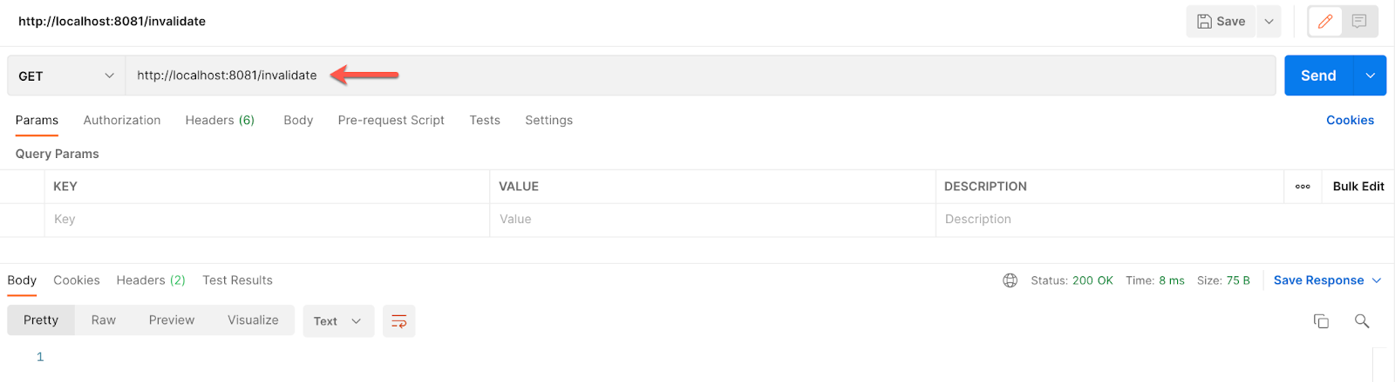

Now, if we try to call the auth_code flow we should get this:

<http://localhost:8081/auth_code> (you can find this endpoint in postman api file in src/test/resources of the github project)

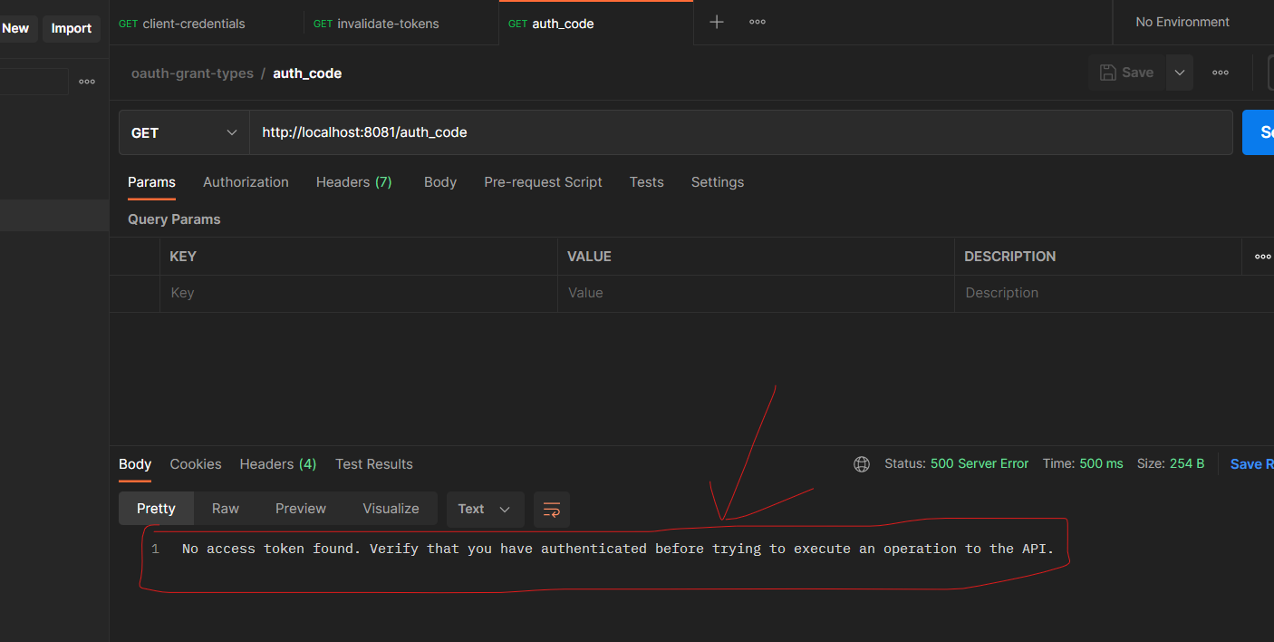

So, we first need to authenticate.

**5.** For that, we go to a new tab on the browser and paste our external callback url:

<http://localhost:8081/login>

If you receive the following error

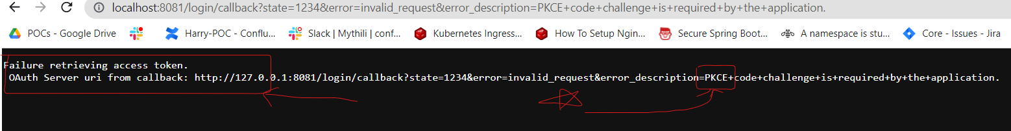

Go to Okta → My Native App → uncheck Proof Key for Code Exchange (PKCE)

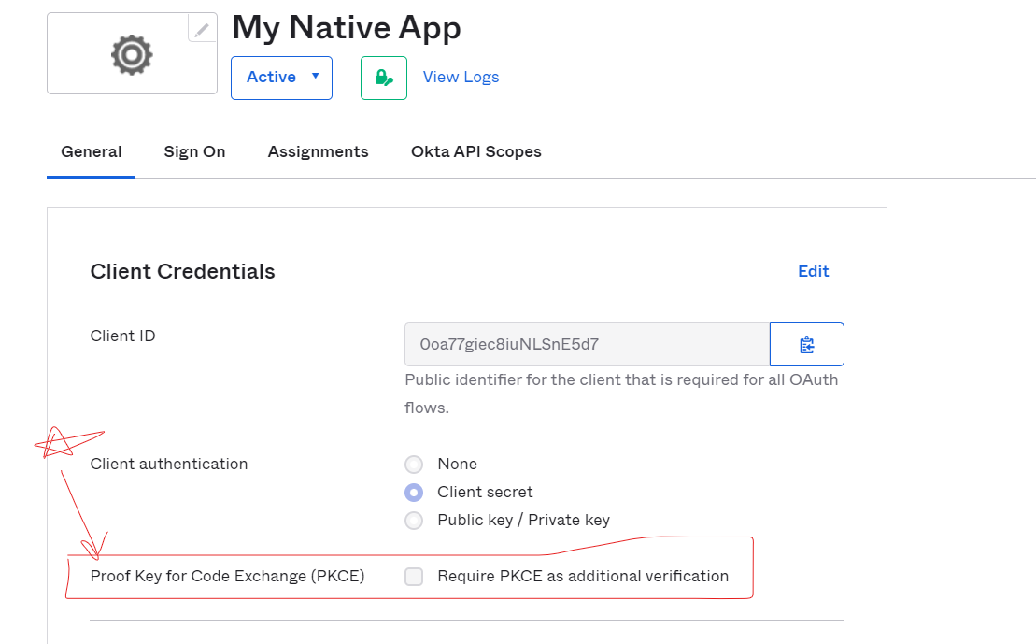

Make a login request again in URL (might take some time to be in effect). It will redirect us to Okta's login page (if you aren't logged in yet) and ask for your credentials.

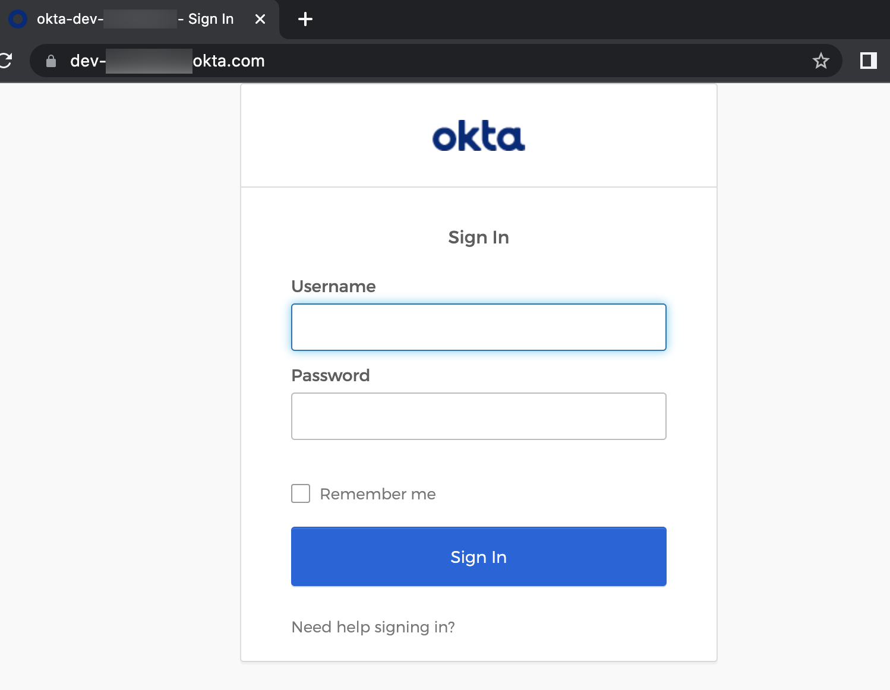

Once logged in, a successful message will appear. In the browser URL you can see the **code** that is retrieving. This **code** is the one that is used to get the **access token** to call the API.

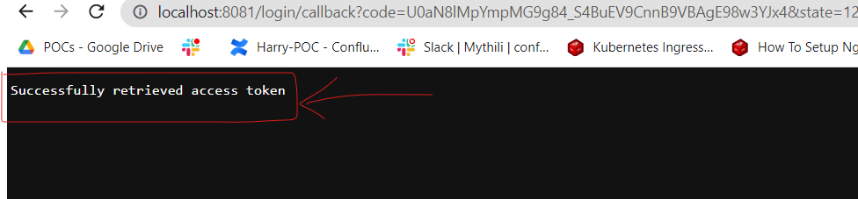

**Note**: If the successful message doesn't appear, just make the request to http://localhost:8081/login again.

This access token is now stored in the Object Store Tokens. So, if we return to Postman and make a call to the auth_code flow, now we'll be able to see the response effectively.

<http://localhost:8081/auth_code> (you can find this endpoint in postman api file in src/test/resources of the github project)

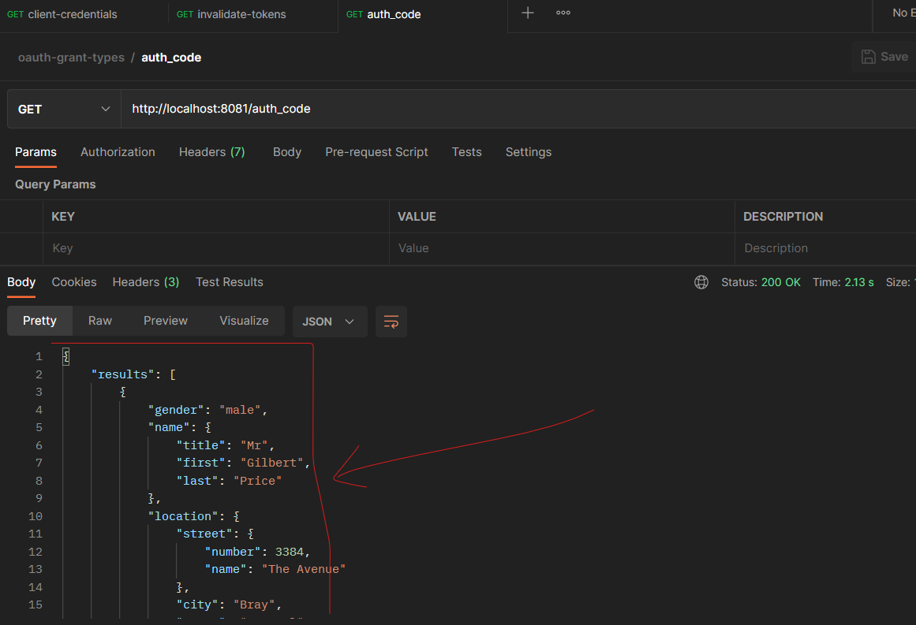

With this, we conclude the **Authorization Code Grant Type** part and we are ready for the next level → **Resource Owner Password Grant Type**!

For this one, we are using the Native App also. This Grant Type and the next one (Implicit) are not predefined in the OAuth Module, so we are going to implement them manually.

**Note**: This Grant Type is also referred to as Password.

**1.** Create a new flow and name it resource_owner_password and another one named get_token. The first flow will have a flow reference to the second one that has all the logic for obtaining the token manually. And then we call the API.

At the end, they will look like this:

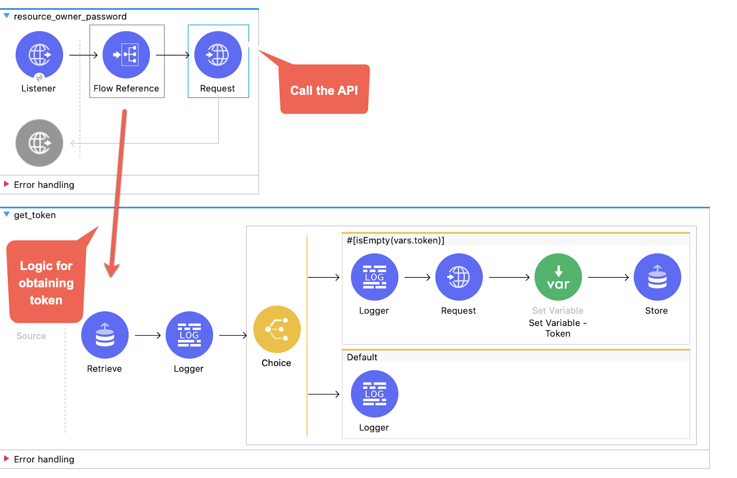

**2.** So, let's begin. In our first flow resource_owner_password drag a **Listener**. Use the default global configuration HTTP_Listener_config and set the path to /password.

Then, drag a **Flow Reference** that references the get_token flow:

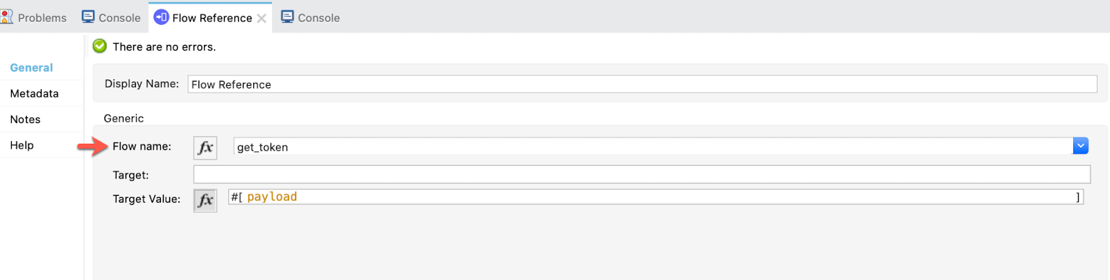

And finally a **Request** with the *default* configuration. As I said, in this **Request** operation the Password and Implicit Grant Types will not be inherited from the **OAuth** module. So, we are using a *default* configuration for both Password and Implicit:

Name: HTTP_Request_congifuration-Resource_Owner-Implicit

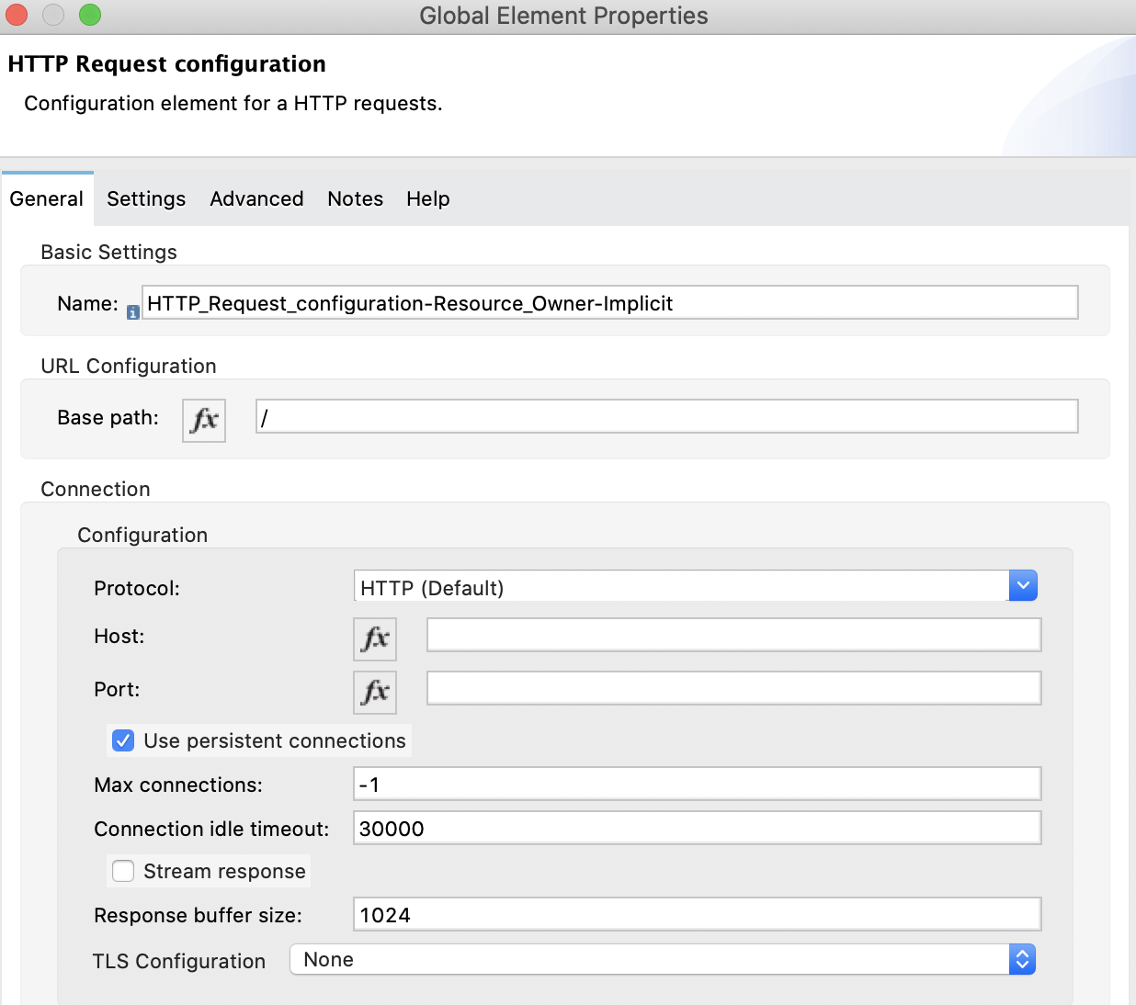

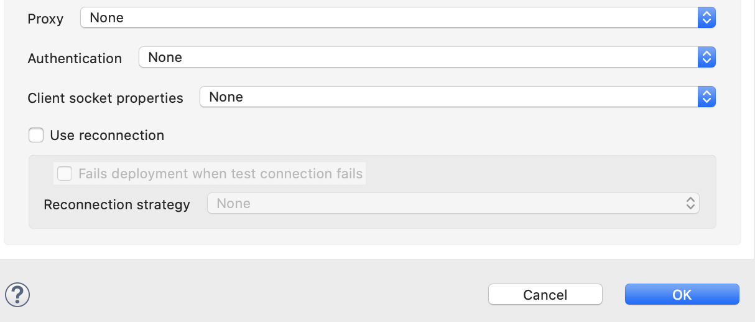

**3.** In the next flow get_token, we start with a **Retrieve** operation. Maybe we already have one token in the Object Store so we are checking:

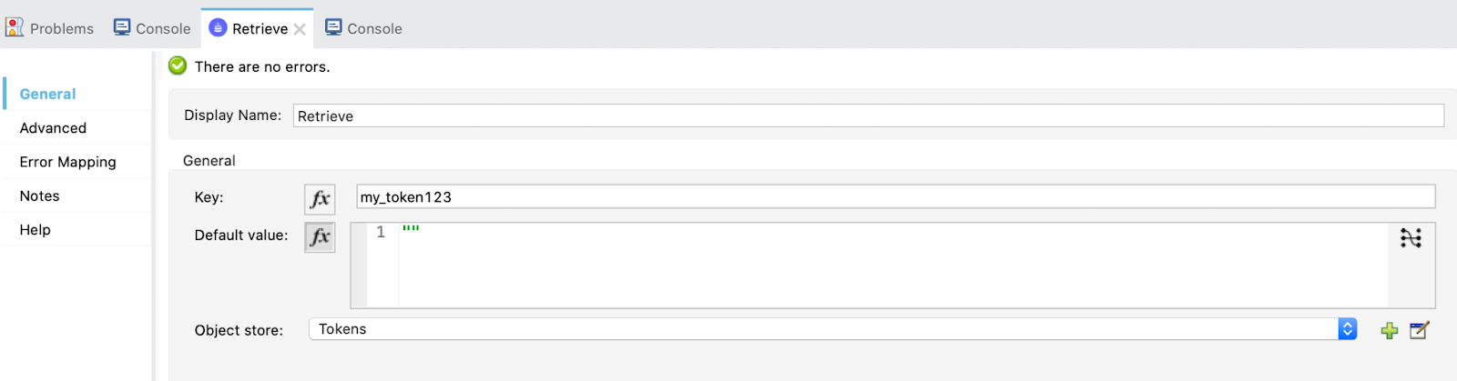

Also, in the advanced tab, put a target variable and value so that the payload is not overwritten.

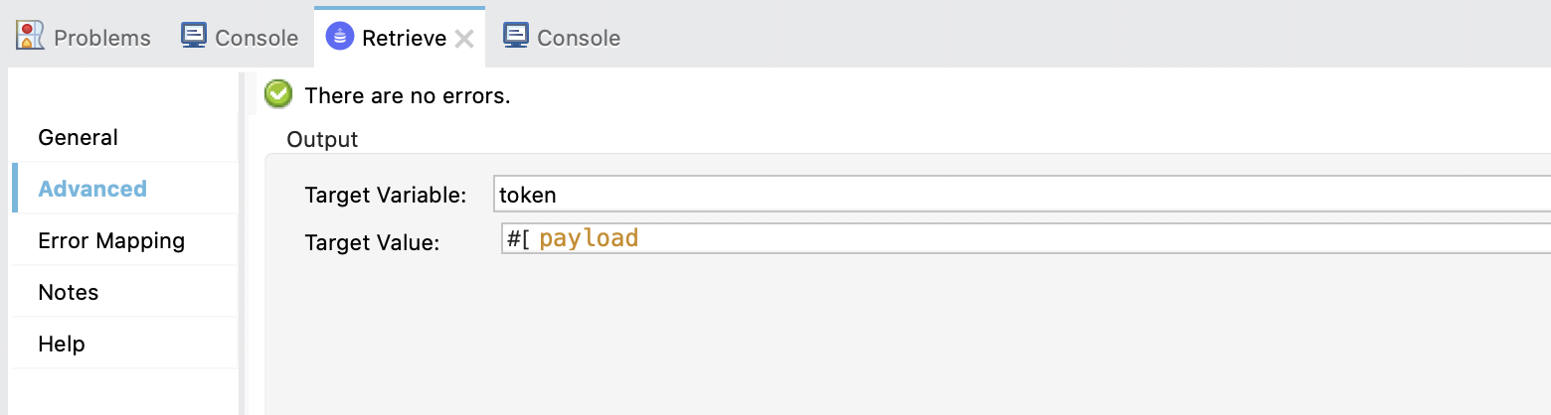

**4.** Drag a **Logger** to see the *payload*.

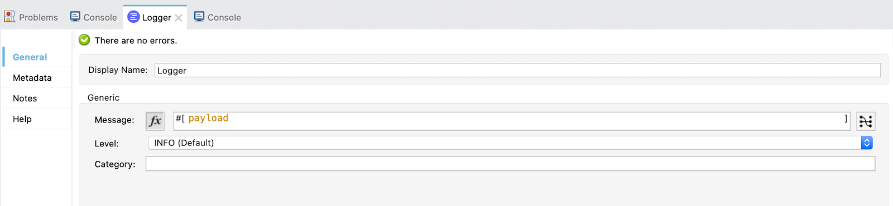

**5.** Now, drag a **Choice** operation. If we already have a token we will log that the token is found and continue by calling the API in the upper flow. But, if we don't have a token, we will make a Request to Okta to obtain it.

The first **When** element has the following expression:

isEmpty(vars.token)

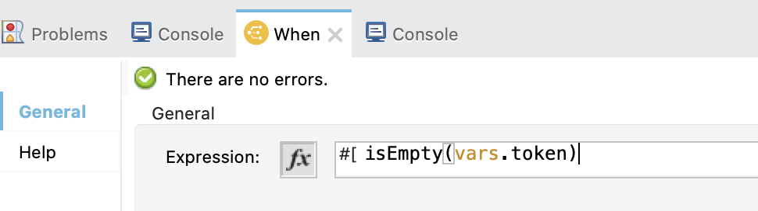

And the second **When** element is the default and has a **Logger** printing that the token has been found.

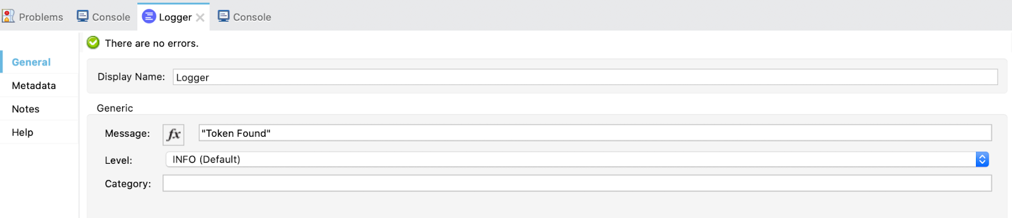

**6.** Let's take a deeper look at the first **When** element.

It first logs that the token wasn't found:

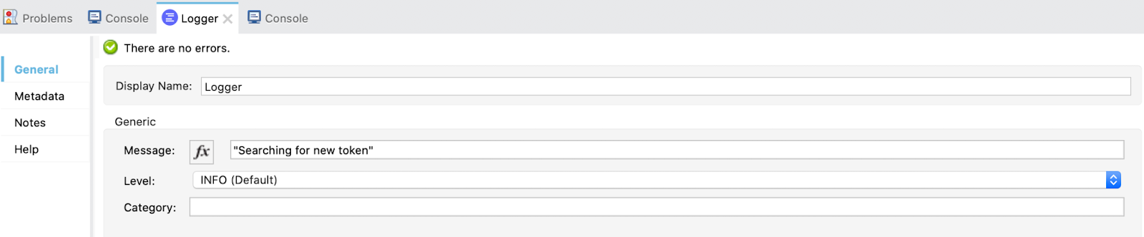

Then, it makes the **Request** to *Okta* with the following configuration:

Name: HTTP_Request_configuration-Okta

Host: ${okta.domain}

Protocol: ${okta.port}

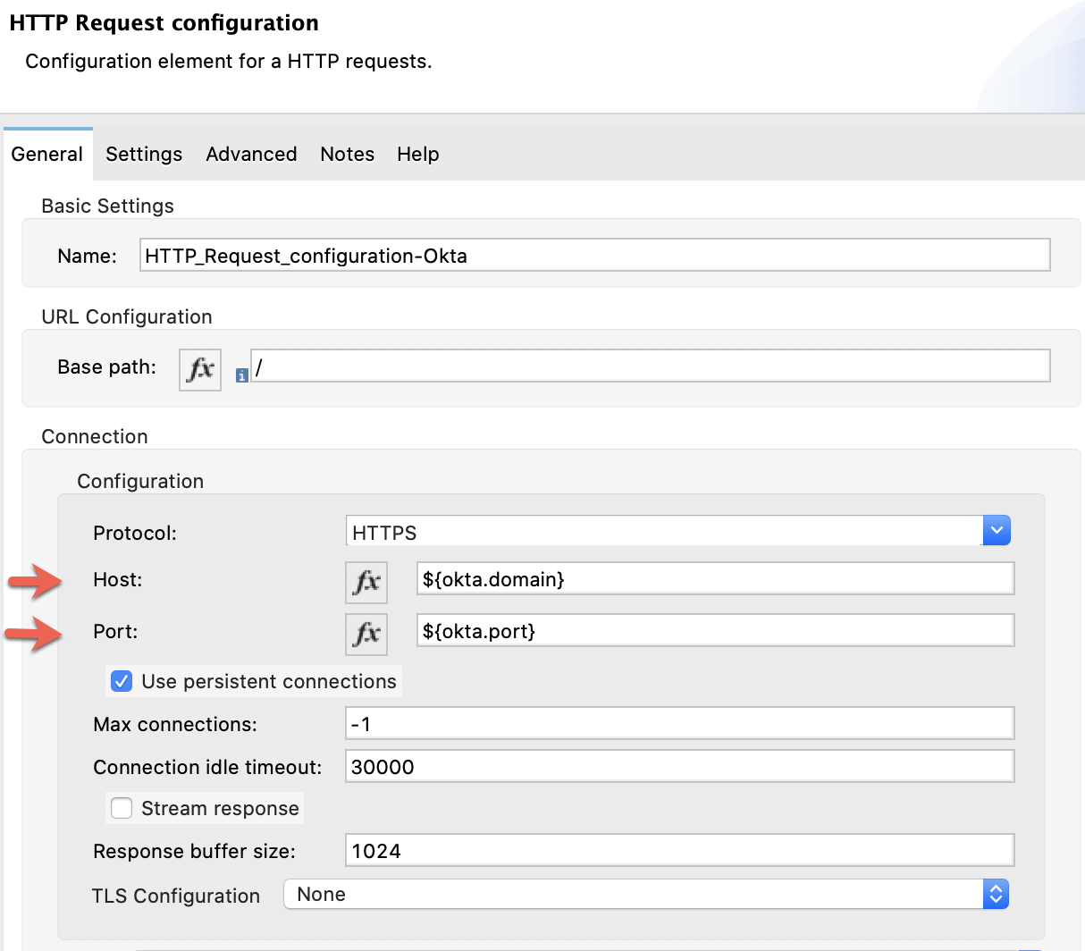

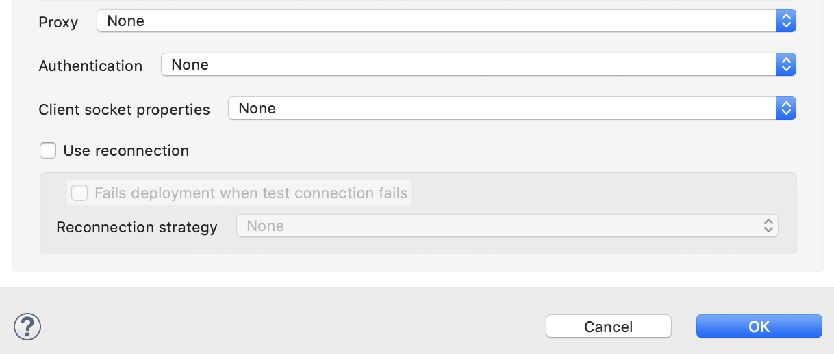

We set the path to:

${okta.token_path}

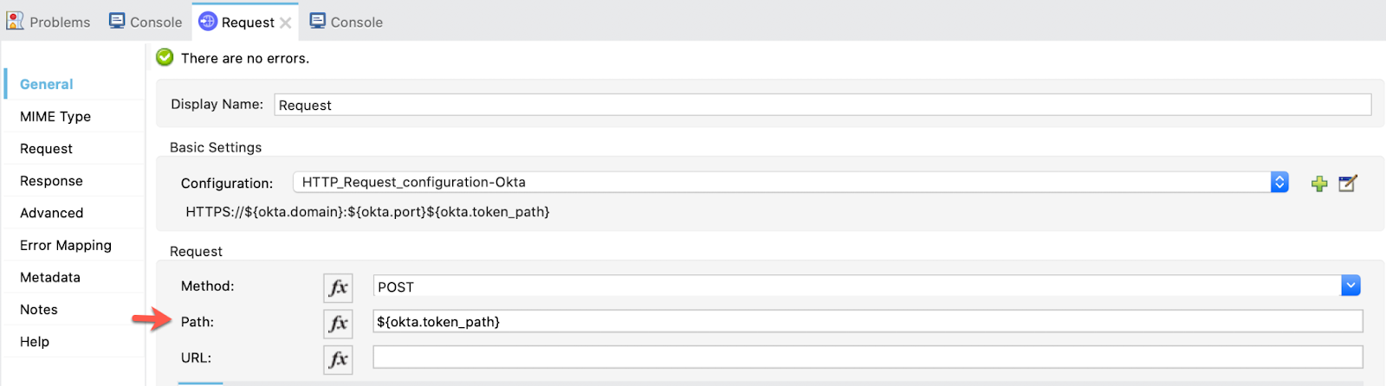

And the we configure the **Request** manually:

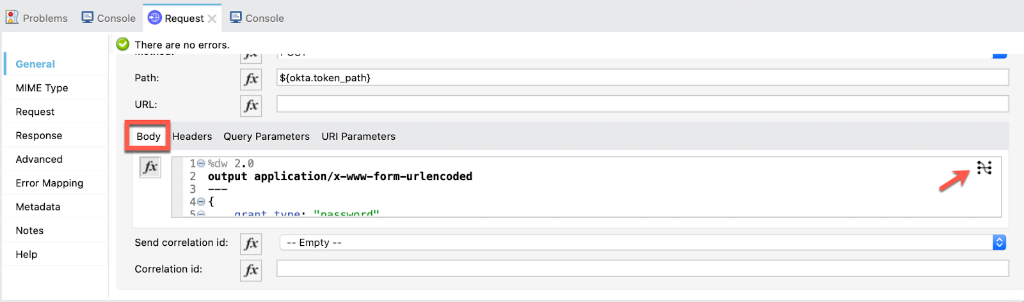

%dw 2.0

output application/x-www-form-urlencoded

---

{

grant_type: "password",

redirect_uri: p('native_app.redirect_uri'),

username: p('okta.username'),

password: p('okta.password'),

scope: p('native_app.scope'),

client_id: p('native_app.client_id'),

client_secret: p('native_app.client_secret')

}

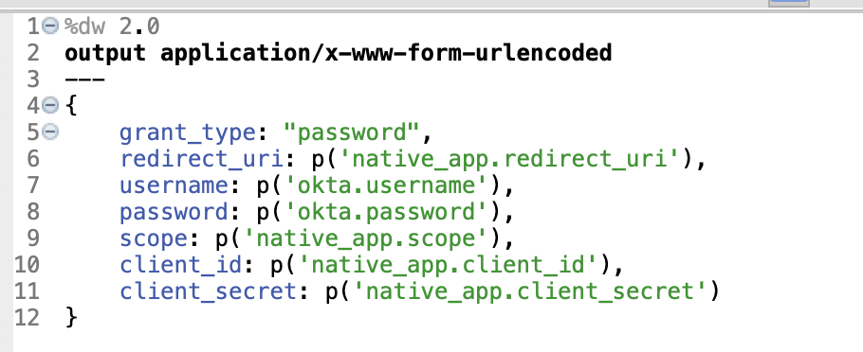

**Note**: The ‘p(String)' returns a string that identifies the value of one of these input properties: Mule property placeholders, System properties, or Environment variables.

Select *Done* and we pass to the *Headers* now:

"Accept": "application/json"

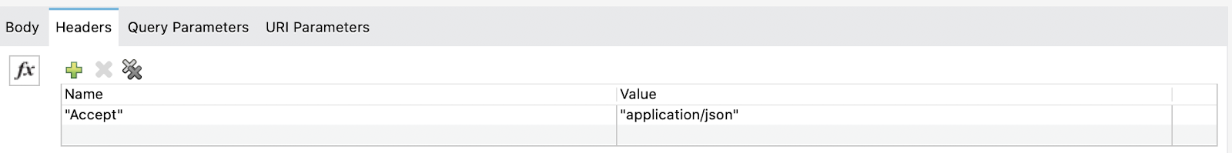

The **Request** configuration is finished. Now, drag a **Set Variable** to set the value of payload.access_token to the variable token:

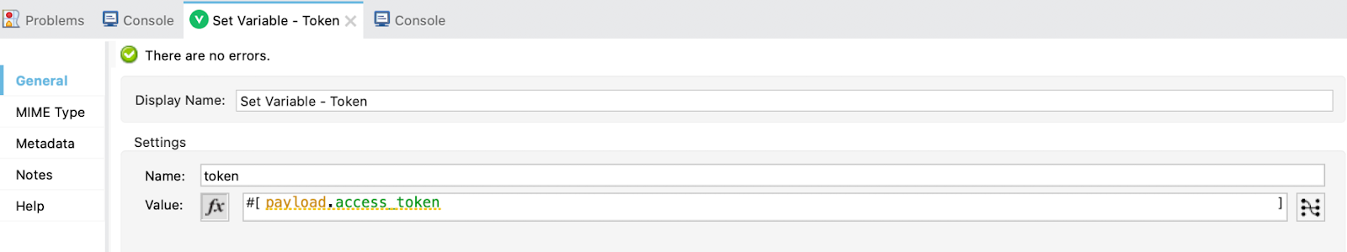

Finally, store the token by using a **Store** operation:

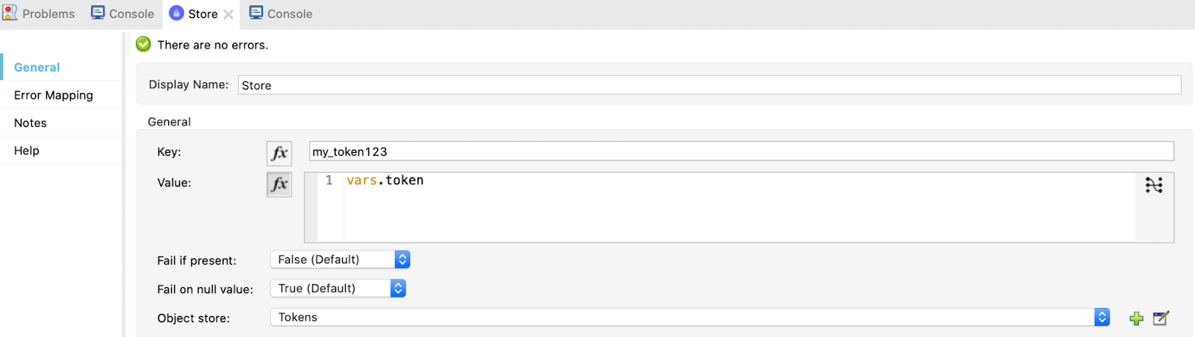

When this is complete, a call will be made to the API using the access token.

With this, we finish the entire flow for implementing the Password Grant Type. Now, we are going to test it.

**7.** Go to Postman, and make a **GET** Request first to /invalidate for later appreciate the difference between searching for a new token in *Okta* and already having a token:

<http://localhost:8081/invalidate> (you can find this endpoint in postman api file in src/test/resources of the github project)

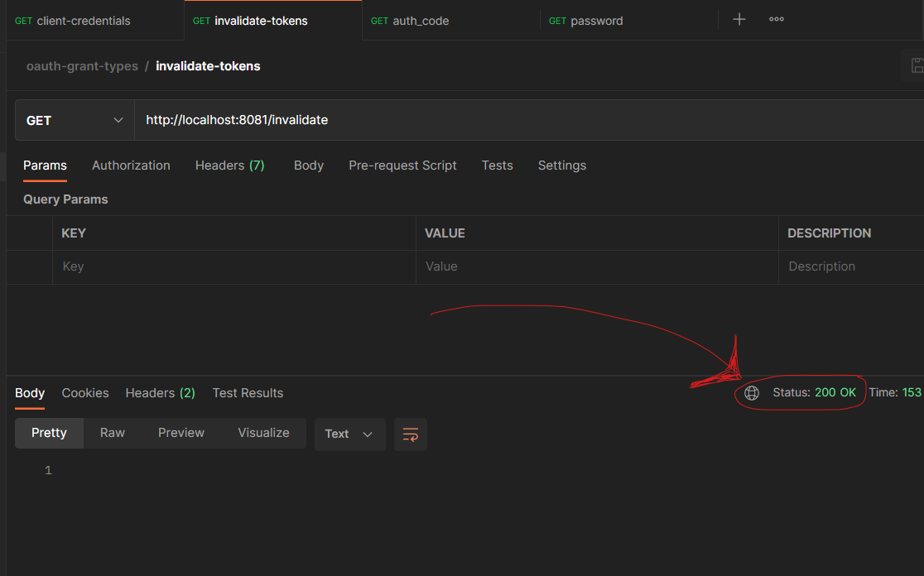

Now, make a **GET** Request to:

<http://localhost:8081/password> (you can find this endpoint in postman api file in src/test/resources of the github project)

It may take a little bit to get the token because we are obtaining it from Okta now and then making a second Request to the API. But you'll see the response in 2 or 3 seconds.

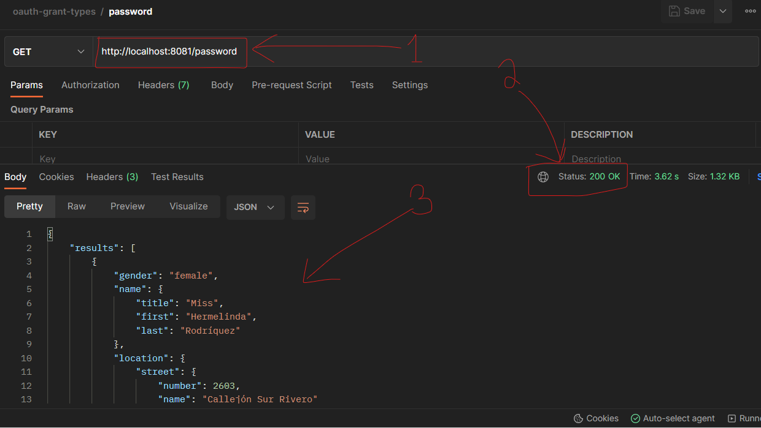

If we go to the *Console* in Studio we can see the **Logger** printing *"Searching for new token"* (scroll up a little bit):

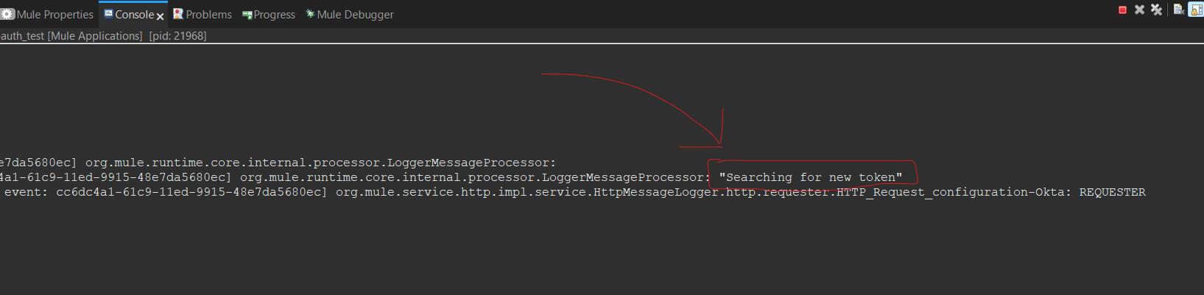

If we make a Request again to /password we'll get the response almost instantly because we are using the stored token now!

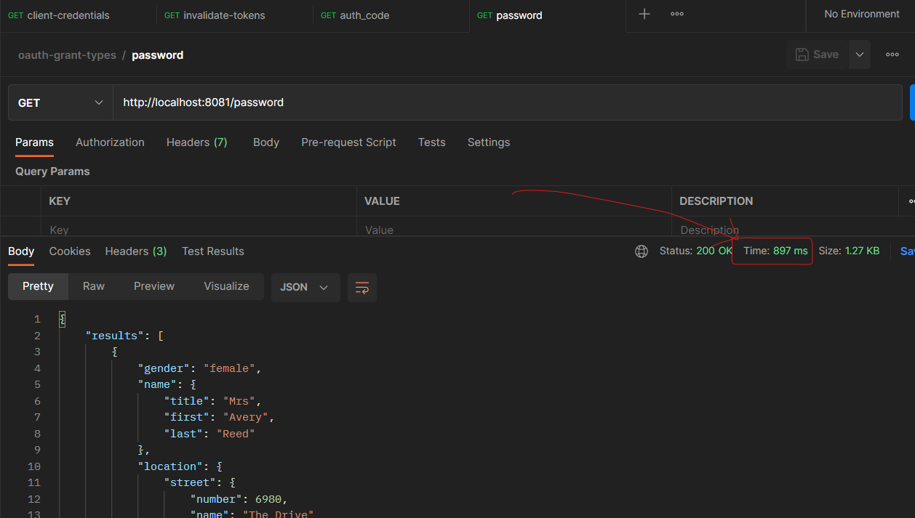

And in the **Console** of Studio we can see the **Logger** printing "*Token found"* (the second **When** element of the **Choice** Router):

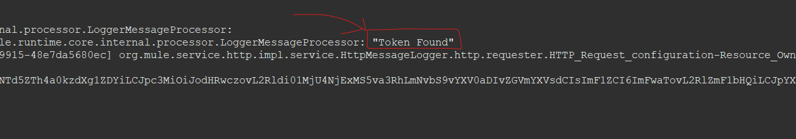

With this, we finish the Resource Owner Password Grant Type demonstration!

Let's go to the **LAST ONE** of them, the Implicit Grant Type and finish this Codelab!

We reached the last step! With this Grant Type we are also using the Native App in *Okta*.

For the implementation of this one, we are going to create 4 flows and play a little bit with *DataWeave* and with a script of *HTML*. A big part of the complexity of this one is because it's not meant to be automated as we mentioned in the beginning.

It's really interesting, so, let's get down to work!

**1.** First, let's take a look at how all this is going to work.

Here are the 4 flows we are going to implement:

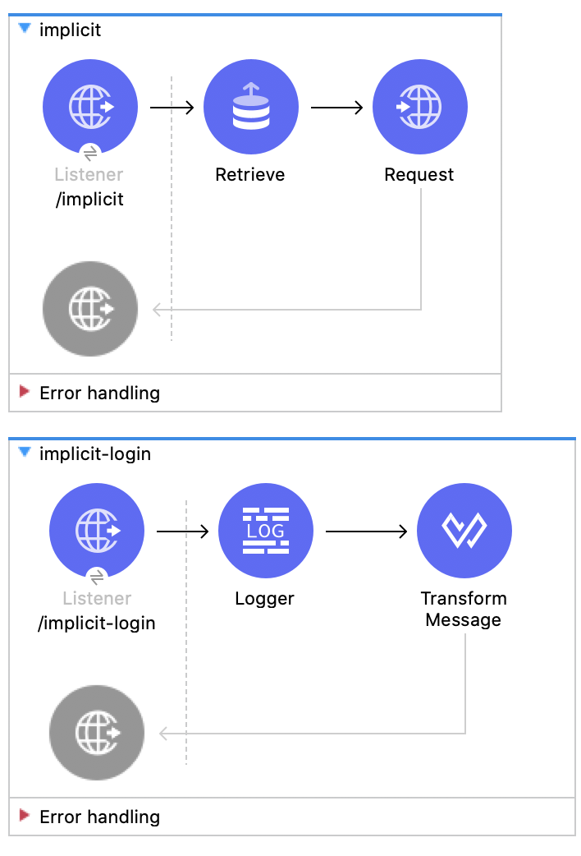

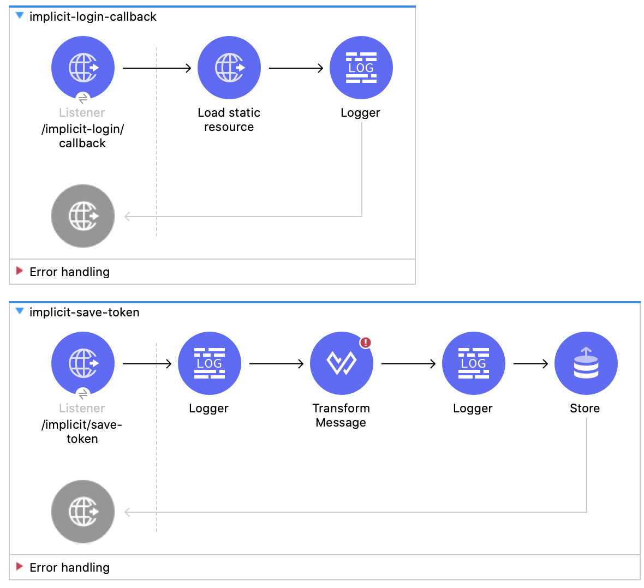

And, for better understanding, here is a **Sequence Diagram** of how all this works:

**FIRST PART** (obtaining the Access Token from Okta):

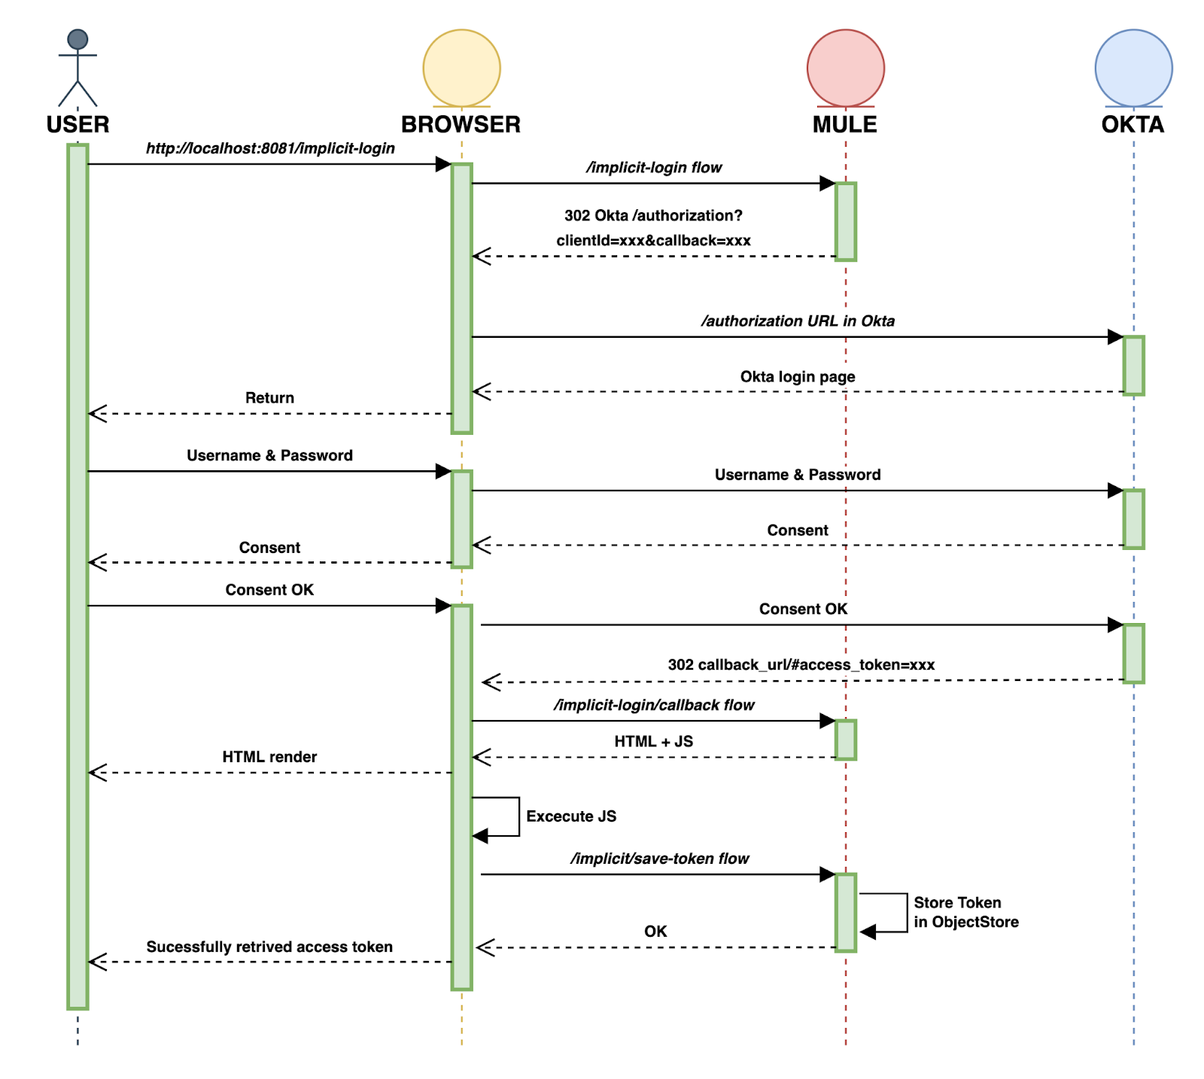

**SECOND PART** (calling the /implicit flow from Postman to GET the API Response):

**2.** Before implementing everything in Studio, we need to go back to Okta to add this new callback.

Go to the Native App general tab and select the **edit** button. Scroll down to *"Sign-in redirect URIs"* and add the new callback http://localhost:8081/implicit-login/callback.

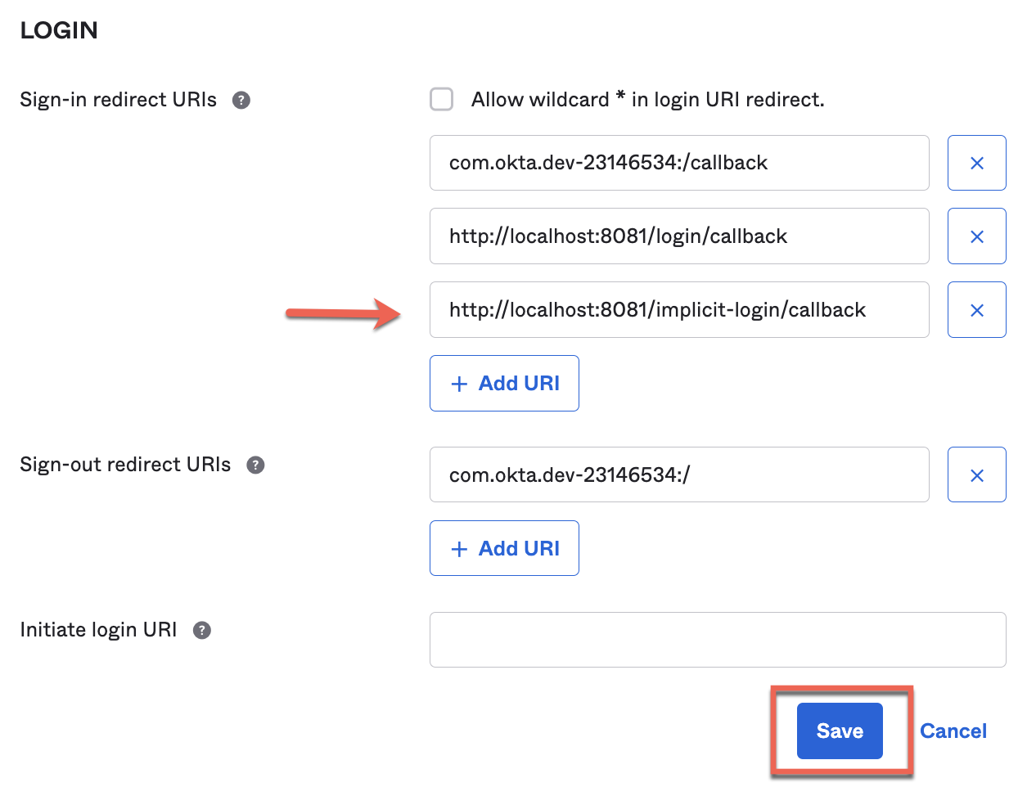

And **Save** it.

**3.** Alright, let's begin implementing the first flow.

Create a new flow and name it implicit-login. This is the one that will interact with *Okta* and redirect us to the callback using a **302** status code.

Drag a Listener, select the default HTTP_Listener_configuration and set the path to /implicit-login.

Then, go to the responses tab. In the Headers section add vars.respHeaders and in Status code write 302. This is to perform the *redirect*.

**Note**: The variable ***respHeaders*** will be then defined in the transform message at the end of this flow.

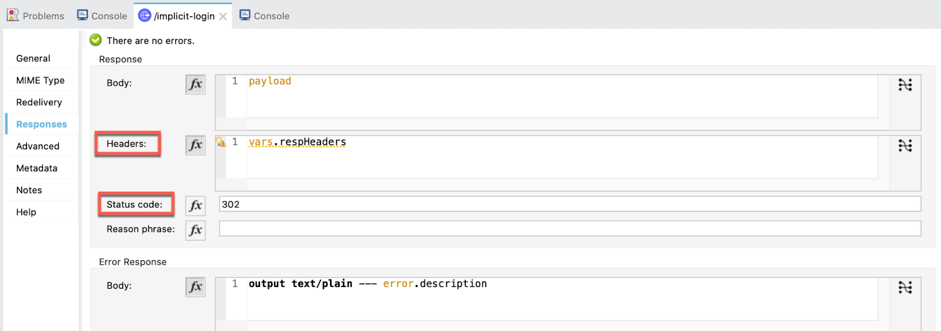

Drag a **Logger** just to keep track of which flow is executing:

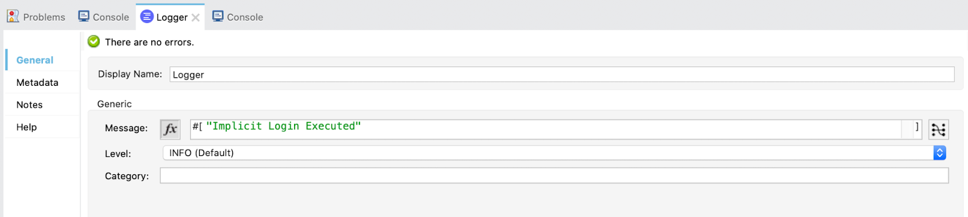

And at the end, add a **Transform**. Select the output to be the *variable* respHeaders and write the next *DataWeave* code to perform the redirect:

%dw 2.0

output application/java

var queryParams = {

client_id: p("native_app.client_id"),,

response_type: "token",

scope: "openid",

redirect_uri: "http://localhost:8081/implicit-login/callback",

state: "state-296bc9a0-a2a2-4a57-be1a-d0e2fd9bb601",

nonce: "foo"

}

---

{

"Location" : p("okta.auth_url")++"?" ++

((queryParams pluck ($$ ++ "=" ++ $)) joinBy "&")

}

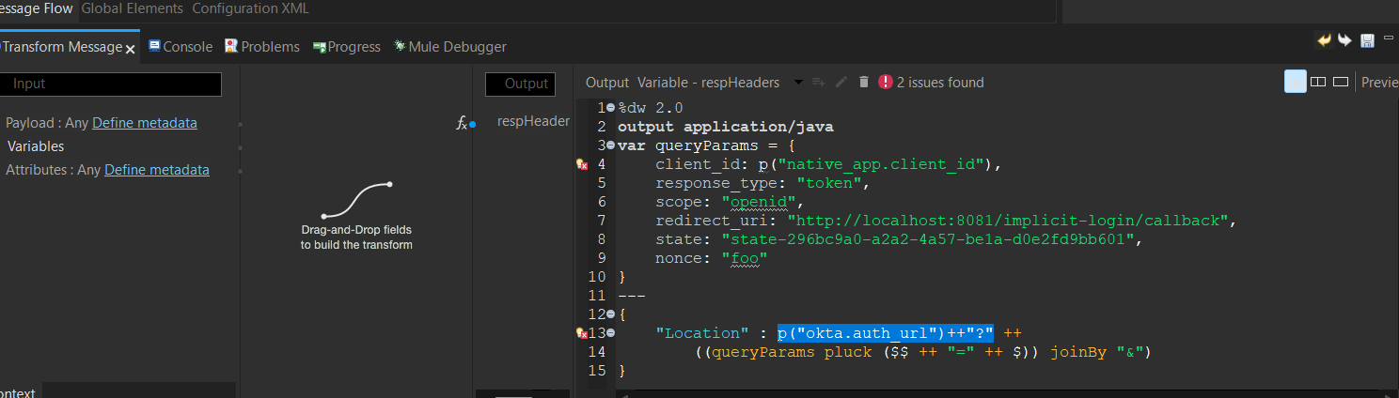

**4.** The next flow to implement is the callback.

Create a new flow and name it implicit-login-callback. This one loads an **HTML** script that is executed in the browser.

What is does is remove from the URL the **hash** (#) before the access token present in the URL. If the hash was there, we wouldn't be able to obtain the token from the URL. So, we need to do this "trick".

First of all, drag a **Listener**, select the default HTTP_Listener_configuration and set the path to /implicit-login/callback.

Now we are going to write the script.

From the **Package Explorer**, go to src/main/resources and create a new file:

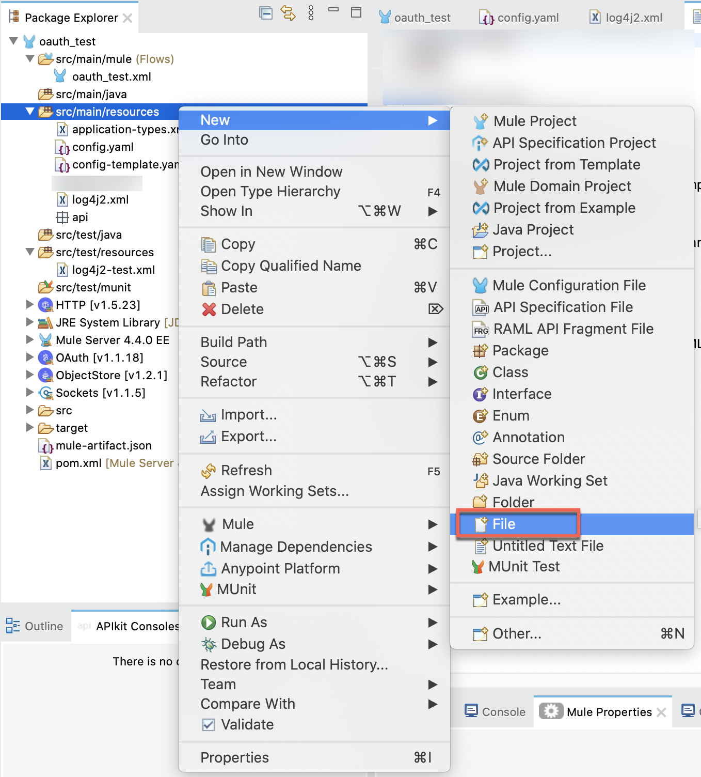

Name it get_url.html.

It will open a new tab in your browser but just go back to Studio. Right click on the file and select "*Open With → Other... "*:

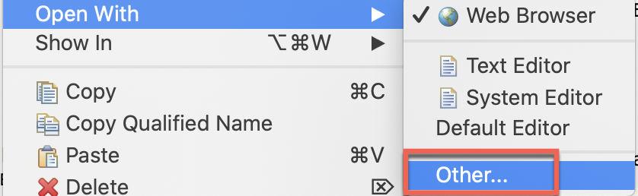

Select "*Internal editors"*, "*Text Editor"* and "*Use it for all ‘*html' files"*:

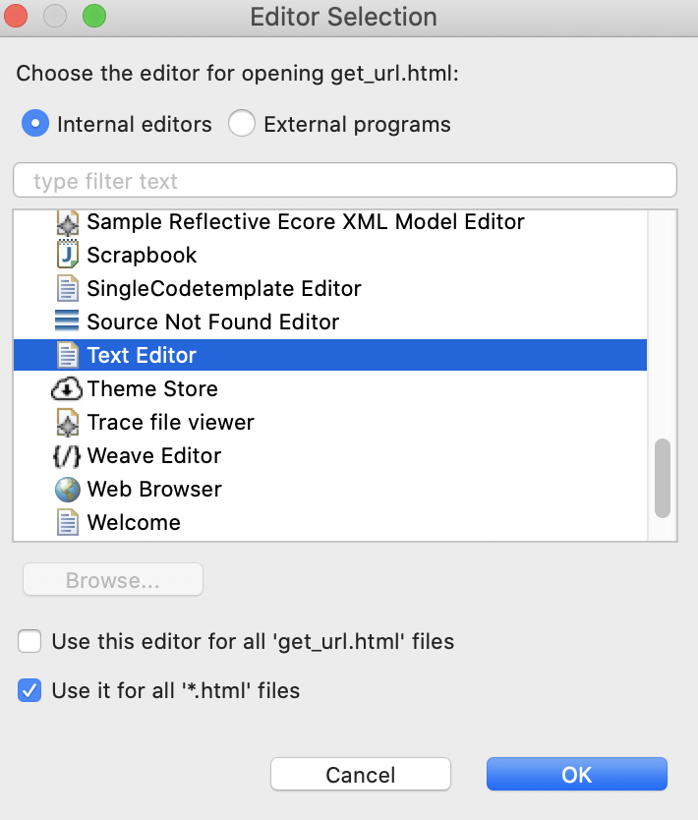

Now, paste this script:

Copy

<!DOCTYPE html>

<html>

<body>

<p id="any"></p>

<p id="status"></p>

<script>

window.onload = function() {

const Http = new XMLHttpRequest();

const url='http://localhost:8081/implicit/save-token?url=' + encodeURIComponent(window.location.href);

Http.open("GET", url);

Http.onreadystatechange = (e) => {

console.log(Http.responseText);

document.getElementById("any").innerHTML = "Successful call";

}

Http.send();

};

</script>

<script>

document.getElementById("any").innerHTML =

window.location.href;

</script>

</body>

</html>

This script is calling the last flow implicit-save-token and saving the entire URL in a Query Parameter named url. Then we will access that url and get the access token.

Once the script is ready, go back to the implicit-login-callback flow and drag a Load static resource operation. Configure as this:

Resource base path: ${static_resource.path}

Default file: get_url.html

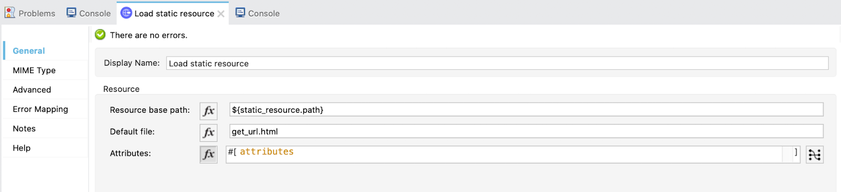

Now is time to go back to the config.yaml and set the path where the script is.

In my case is like this:

"/Users/aemiliani/Documents/Andres/Workspaces/Security Training/oauth_test/src/main/resources"

In your case it will be different. If you want to find the path/location of the file easily, you can right click in the folder src/main/resources and select Properties.

From there, copy the entire path (the one next to Location) and then close this window:

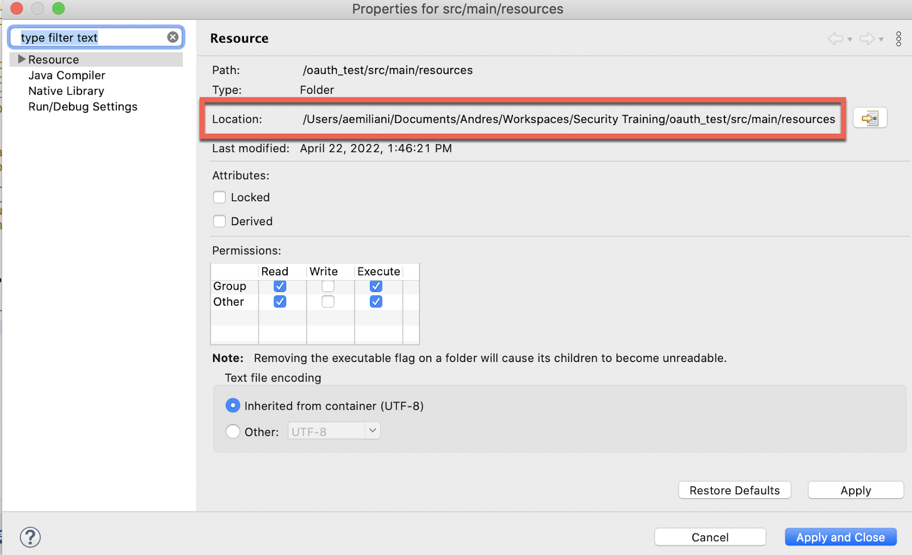

Now paste it in the config.yaml



Go back to the implicit-login-callback flow and add a **Logger** to log the *payload*.

**5.** That was all for the callback, now, we are going to implement the flow to save the token for later using it in the implicit flow to call the API.

Create a new flow and call it implicit-save-token. This flow will get the access token in the URL that the implicit-login-callback flow obtained and it will save it in the Object Store Tokens that we created.

Drag a **Listener**, select the default HTTP_Listener_configuration and set the path to /implicit/save-token.

Drag a **Logger** to control that the URL we are getting is OK.

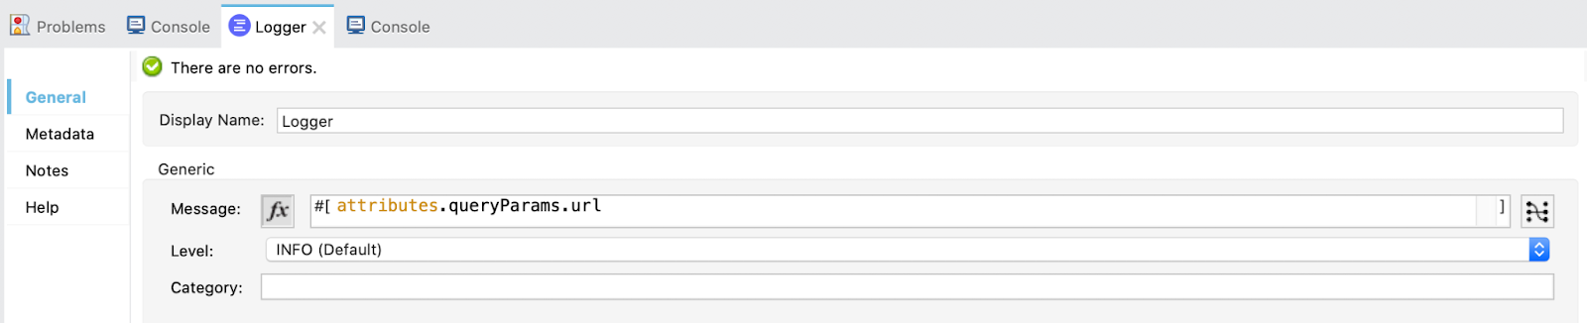

Then, add a **Transform** component. Select the *Output payload* and paste this DataWeave code:

%dw 2.0

import * from dw::core::URL

output application/java

---

{(splitBy(parseURI(attributes.queryParams.url).fragment, "&") map (

do {

var param = $ splitBy "="

---

{

(param[0]): param[1]

}

}

))}.access_token

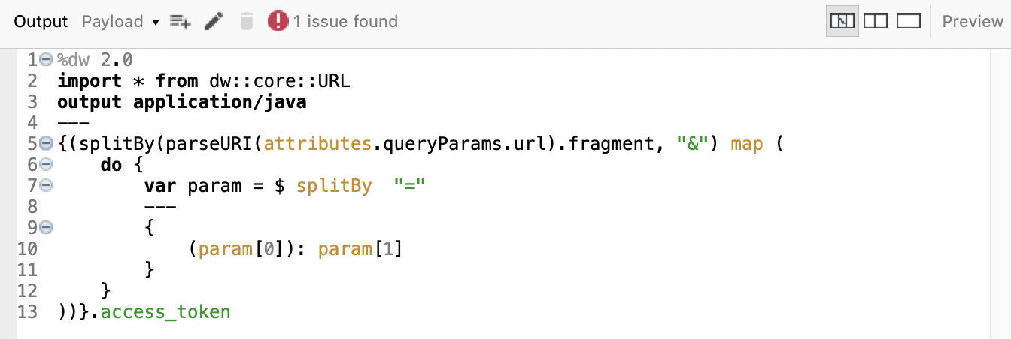

This code is getting only the access token from the URL we got and passing it to the next processors as the payload.

**Note**: Don't pay attention to the *"issue"*, it is nothing relevant, you can Run the program without inconvenients.

Drag a **Logger** to log the payload, that should be only the access token.

Finally, add a **Store** operation from the *OAuth module* to store the access token obtained.

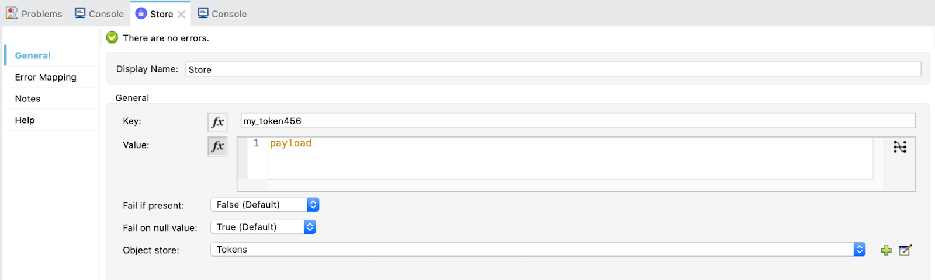

This is all for the flow to save the token!

**6.** Finally, the last one...

Create a new flow and name it implicit. This one just gets the access token and calls the Random User API.

Drag a **Listener**, select the default HTTP_Listener_configuration and set the path to /implicit.

Drag a **Retrieve** operation from the *OAuth* module and configure like this:

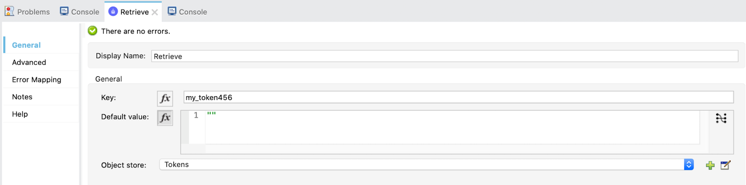

Here we are obtaining the token for then calling the Random User API.

In the advanced tab, add a target variable and value:

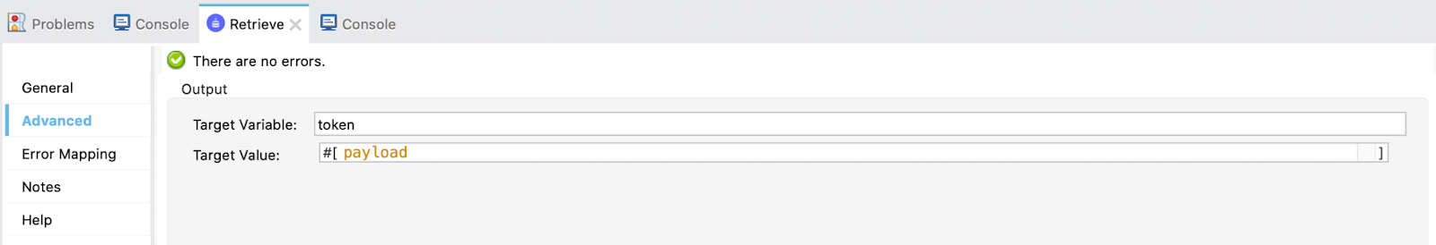

Finally, call the API. Drag a **Request** and select the HTTP_Request_configuration-Resource_Owner-Implicit (the same we used for **Resource Owner Password** Grant Type) and add the in the URL ${api.url}.

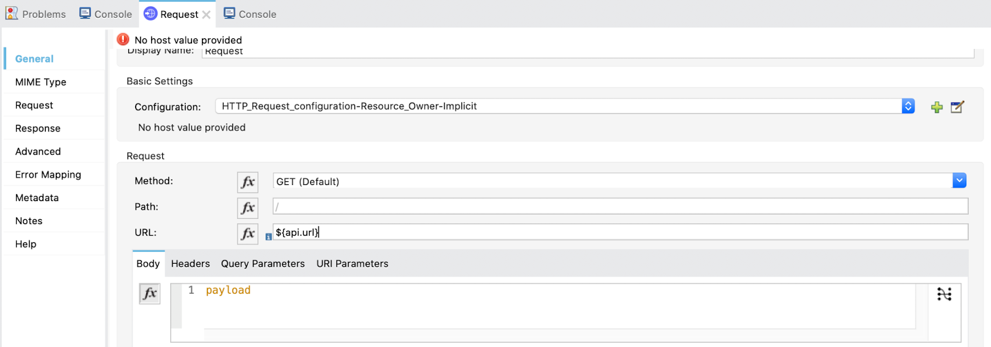

We are all set! Now let's try it out!

**6.** Same as in Auth Code flow. First make a GET request to:

<http://localhost:8081/invalidate> (you can find this endpoint in postman api file in src/test/resources of the github project)

The response will be empty but it is cleaning up the stored tokens.

Then, if we try to call the implicit flow we should get this:

<http://localhost:8081/implicit> (you can find this endpoint in postman api file in src/test/resources of the github project)

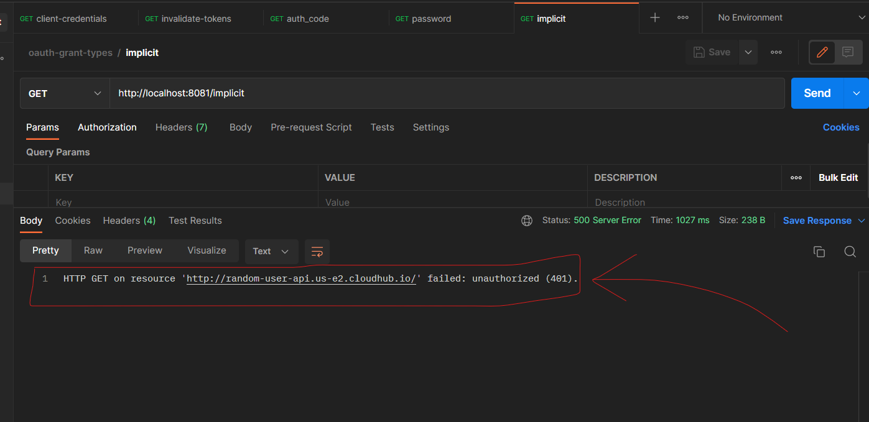

We first need to authenticate.

Open a new tab in your browser and call the implicit-login flow:

http://localhost:8081/implicit-login

It will redirect us to Okta's login page (if you aren't logged in yet) and ask for your credentials.

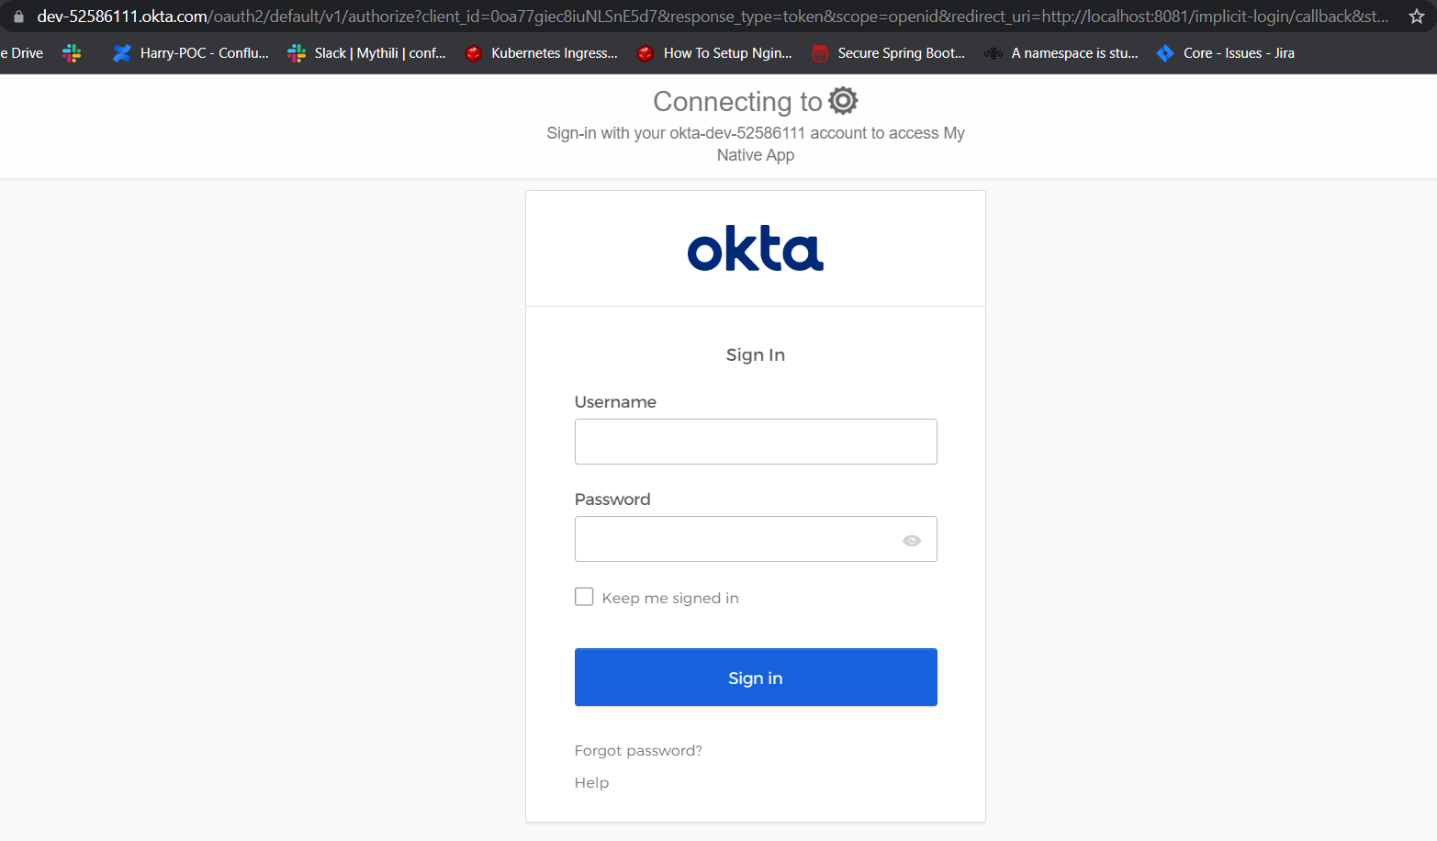

Once logged in, a successful message (*"successfully retrieved access token"* or *"successful call"*, something like that) will appear. In the browser URL you will be able to see the unaccessible access token with the hash **#** before.

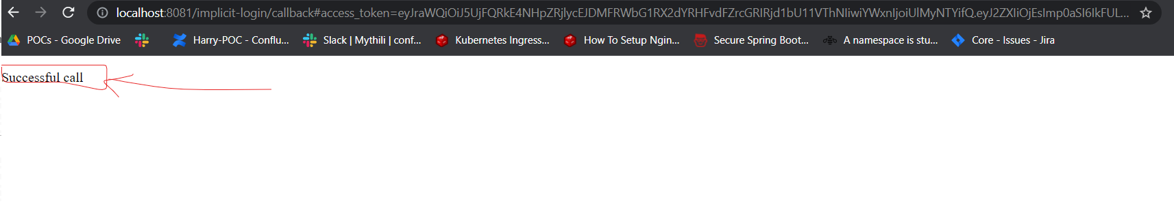

**Note**: If the successful message doesn't appear, just make the request to http://localhost:8081/implicit-login again.

The ‘magic' will be done and the access token is now stored in the Object Store Tokens.

Return to Postman and make a GET request again to:

<http://localhost:8081/implicit> (you can find this endpoint in postman api file in src/test/resources of the github project)

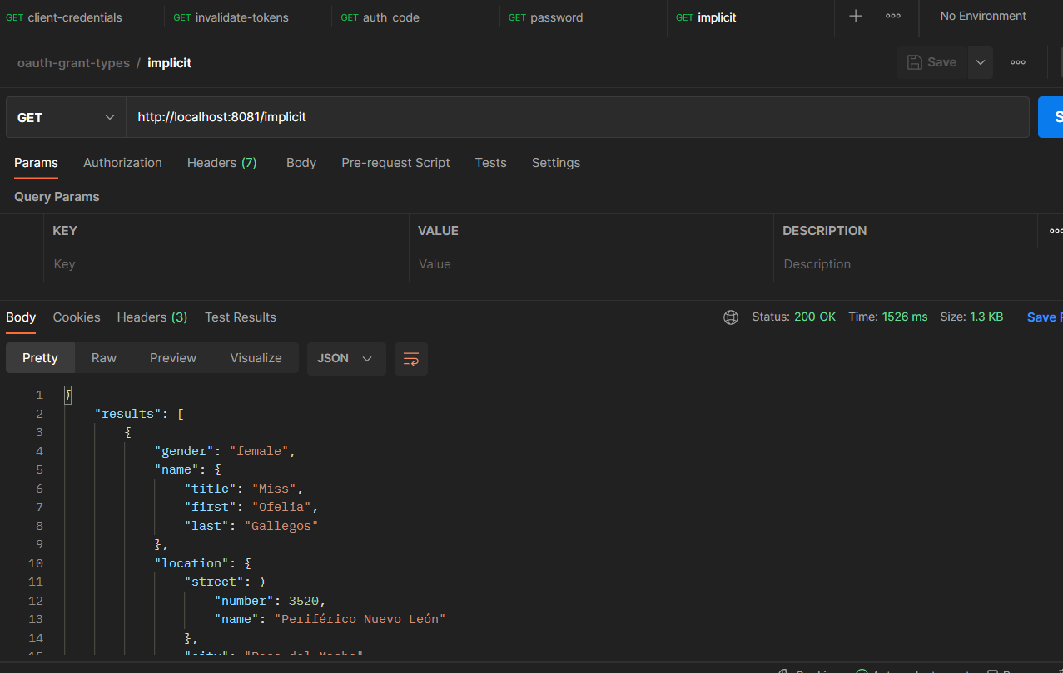

And there is the response! This is great, we've got to the end of this tutorial. But, there is one more thing... just jump to the next step!

If you want to learn more about **Okta**, **OAuth 2.0**, **Anypoint Platform**, **Anypoint Studio** and how to set up **Client Management**, here is a Codelab I wrote for you:

<https://conflowence.atlassian.net/l/cp/pxMyh8wW>

Thank you for reading! I hope you could make it to the end and I hope you enjoyed the Codelab!

😎😎😎

